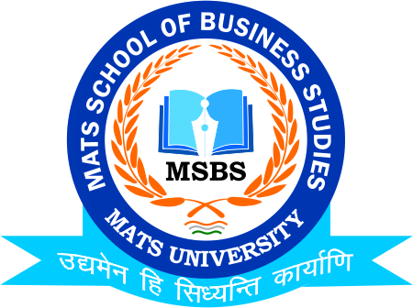
NOTICE
International Women Day
Date: 8th March 2021

Date: 8th March 2021

This is to inform to all the Students of B.Com & M.Com that the MATS School of Business Studies in coordination with MATS University is going to organize a grand event on International Women Day at MATS Atrium on 8th March 2021, So all the Students of respective Classes are instructed to assemble at the Venue well on time .

HOD
MSBS
Dated: 8th March 2021
Raipur

