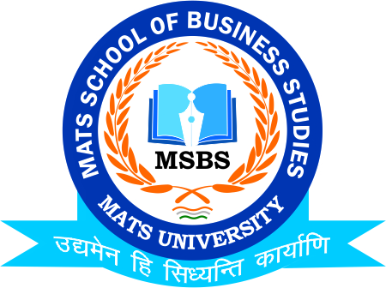

Time- Table (Mid Term Examination) March-2021
MATS School of Business Studies
 | B.Com-IV (Hons.) | B.Com-VI (Hons.) | M.Com-IV
Date /Time | 1:30-3:30 | 12:30-02:30 | 3:00-5:00
15th March 2021 (Monday) | Cost Accounting | ---- | ----
16th March 2021  (Tuesday) | ---- | Advance Financial Accounting | E-Ship & Customer Relation Mgt.
17th March 2021  (Wednesday) | GST Law & Other Law Practise | ---- | ----
18th March 2021  (Thursday) | ---- | Investment on Stock Exchange | Corporate Governance Business Ethics, CSR
19th March 2021  (Friday) | Income Tax Law & Practise | ---- | ----
20th March 2021  (Saturday) | ---- | Advertising & Sales Management | Financial Mgt.& Policy
22nd March 2021  (Monday) | Principles of Auditing | ---- | ----
23rd March 2021  (Tuesday) | ---- | ---- | International Financial Mgt.
24th March 2021  (Wednesday) | Human Resources Management | ---- | ----

Note:
1. It is compulsory for all students to appear for Mid-Semester examination, which is vital for Internal Marks.
2. No separate test will be conducted for those who Fail Mid-Semester Examination.
3. Mode of Examination will be Offline in MATS Raipur Campus

Date: 3rd March 2021
Dr.Umesh Gupta
Head of the Department
MATS School of Business Studies

