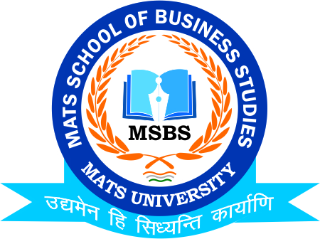

Notice
Session Start January 2021.

MATS School of Business Studies

It’s to hereby inform to all the Students of MATS School of Business Studies that the New Session (January 2021) is going to commence from 7th January 2021 and the Class Timings will be from 9:45 am.
So, all student mentees are instructed to contact their mentors and get their Microsoft Link and get connected for Online Class duly on time
Classes Commencing:-
1.B.Com-IV (Hons.)
2. B.Com-VI (Hons.)
3.M.Com-IV (Hons.)

Date: 4th January 2021
Dr.Umesh Gupta
Head of the Department
MATS School of Business Studies

---000---

