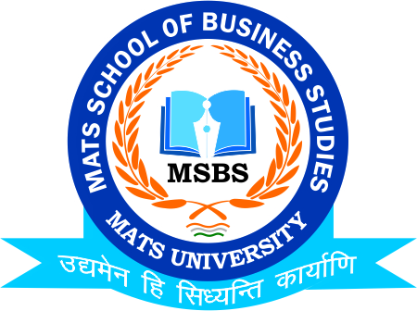

Time- Table (Mid Term Examination), Jan.-2021.

MATS School of Business Studies
 |  | B.COM- SEM-I(H)  (10:00-11:30) | M.Com Sem- I  (12:00-1:30)
Date | Day | Subject | Subject
11th January 2021 | Monday | Financial A/c-I | Statistical Analysis
12th January 2021 | Tuesday | Micro Economics | A/c for Mgrs.
13th January 2021 | Wednesday | Business Law | Org.Theory & Beha.
14th January 2021 | Thursday | Buss.Org.& Mgt. | Mgr.Economics
15th January 2021 | Friday | EVS | Computer App. in Buss.

Note:
1. It is compulsory for all students to appear for Mid-Semester examination, which is vital for Internal Marks.
2. No separate test will be conducted for those who miss/fail mid-sem examination.
3. Mode of Examination will be Online through (Microsoft teams)

Date: 5th January 2021
Dr.Umesh Gupta
Head of the Department
MATS School of Business Studies

---000---

