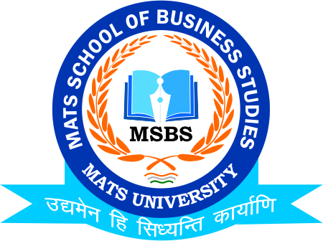
MATS SCHOOL OF BUSINESS STUDIES
“ORPHANAGE VISIT”
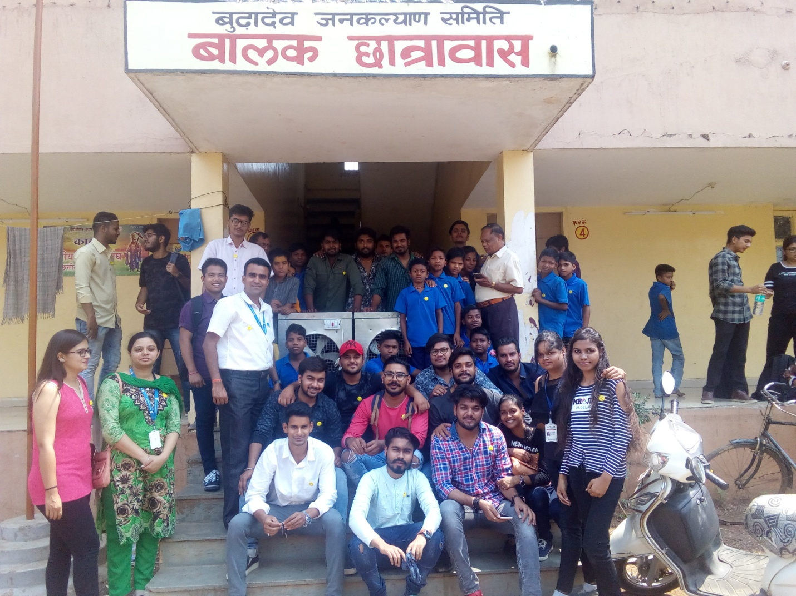
On 13th April 2018 MATS School of Business Studies Organized Corporate Social Responsibility activity to Visit to NGO “ORPHANAGE”-SHRI BUDHADEV JANKALYAN SAMITI Near VIP Road Ramandir Raipur with an object to meet socially Backward Children and also provided basic amenities like Coolers, Writing tools like notes books & Stationeries, and Chocolates and Sweets to children.

MATS School of Business Studies conducted this visit for the students of B.Com & M.Com and two faculty members Mr. Deeptanshu Sharma & Dr..Pushpuinder Kaur Benipal accompanied students and meet and talked to people of NGO & also shared the experiences and children in NGO also talked to the MSBS team.
The Hon Chancellor Shri Gajraj Pagariya, Director General Shri Priyesh Pagaraiya Hon Vice Chancellor Prof. Dr. Byju John, & Registrar Shri Gokulananda Panda express their warm wishes to MSBS Team for conducting this Visit and helped to develop the Children of NGO.
Student’s participation is recommendable, they organized various cultural and others activities and accolade children participation and their wining sprits.

