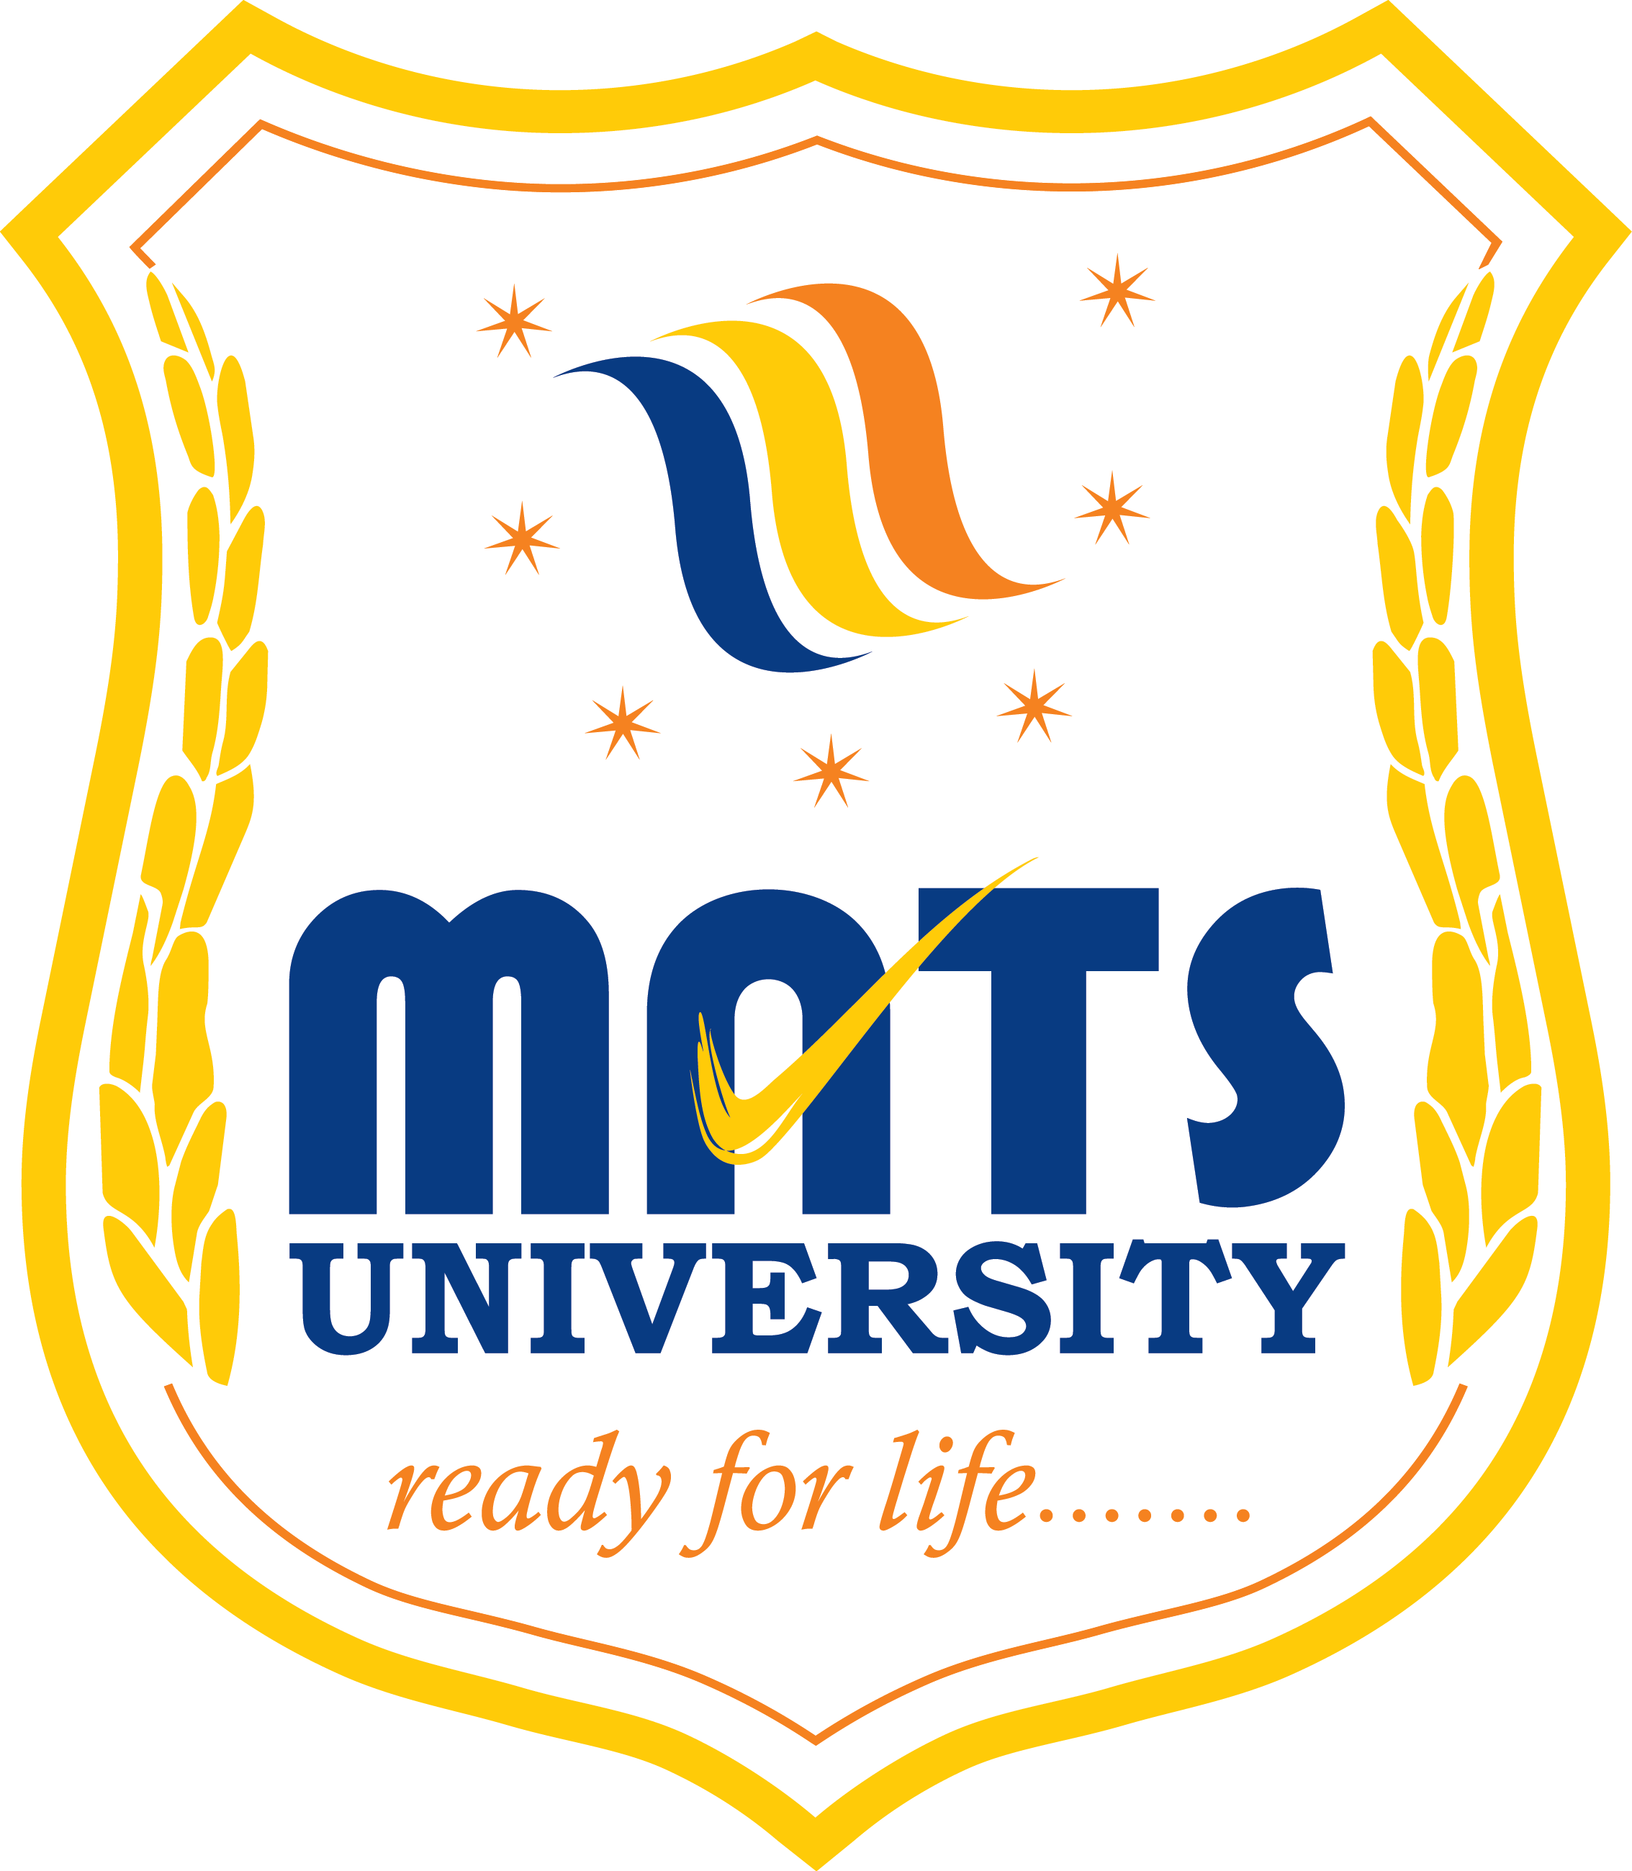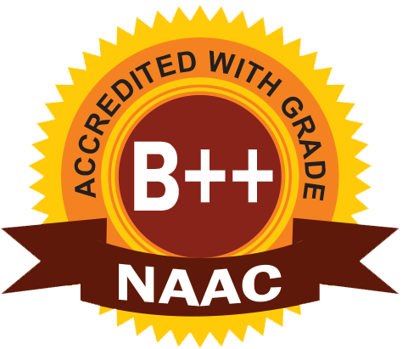
MATS SCHOOL OF FASHION DESIGNING & TECHNOLOGY
EVENT/ ACTIVITY REPORT [Month: FEB-2023]
- Event Details:
- Organized under the aegis of : MATS University, Raipur
- Title : WOMEN EDUCATION AWARENESS
- Date : 11/02/2023
- Time : 10:30 AM
- Venue : GOVT. HIGH SCHOOL BHAVAN, PACHEDA, RAIPUR.
- Mode : Offline
- Type : Visit

2. Attendees/ Participants:
(a) Resource Persons:
(1) N/A

(b) Faculty Attended/ Participated (By Institution/ Programme):

School Name | No. of Faculty attended | Grand Total
MSFDT | 01 | 01

(c) Students Participated (By Institution/ Programme/ Semester).

School (in brief) | Program/Course | Semester | Total No. of students | Grand Total
GHSB | 11th & 12th | - | 22 | 22

3. Event/ Activity coordinator(s):
(1) Mrs. Vijaya Vaishnava

4. Brief description about the event/ activity:

MATS School of Fashion Designing & Technology has conducted “WOMEN EDUCATION AWARENESS ACTIVITY” for the students of 11th and 12th of GOVT. HIGH SCHOOL BHAVAN, PACHEDA, RAIPUR. We explained and made them aware, why Women Education is important for our society? Women education is very important for the empowerment of women. Women education empowers women to make their own independent decisions. It improves the state of women and makes society more equitable and balanced. Thus we see how one educated woman can bring so much change in her life along with the others as well.

5. Learning Outcomes:
- Students are motivated after this activity.
- Students are happy to aware about the women education is important for our society.
- They gained lots of knowledge about education for women.

6. Photographs: (Geo-tagged photographs)
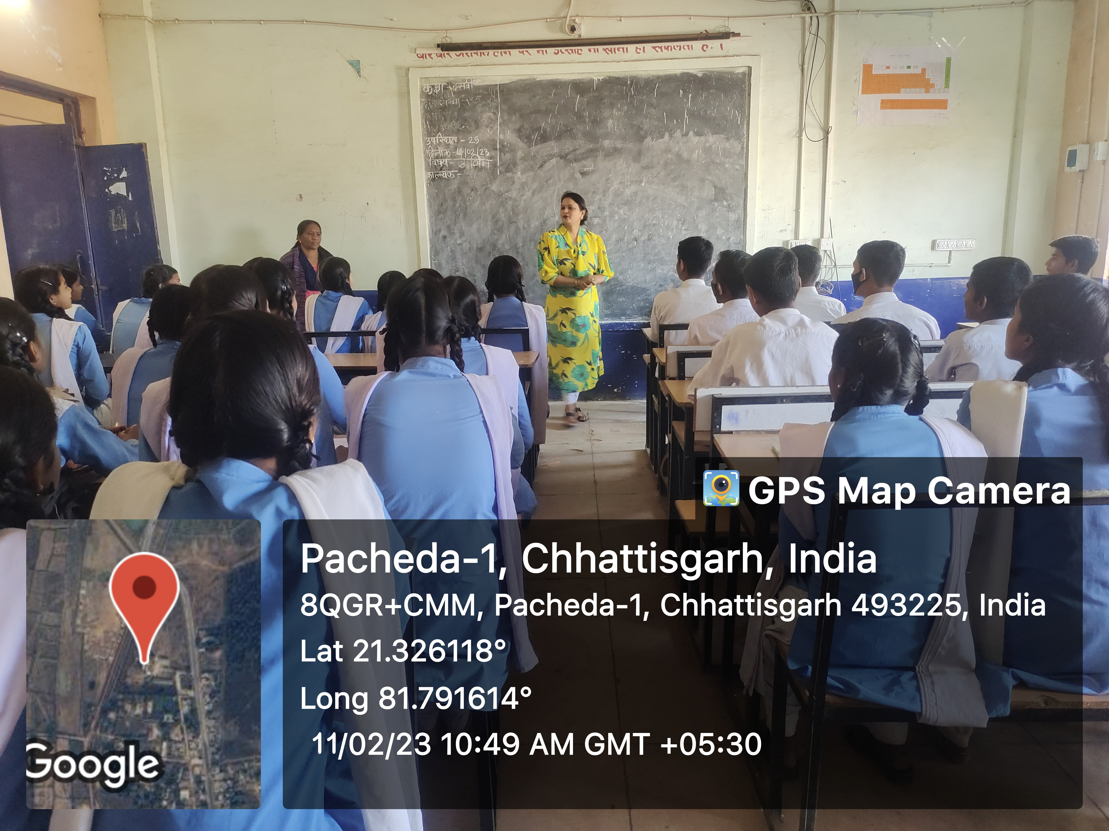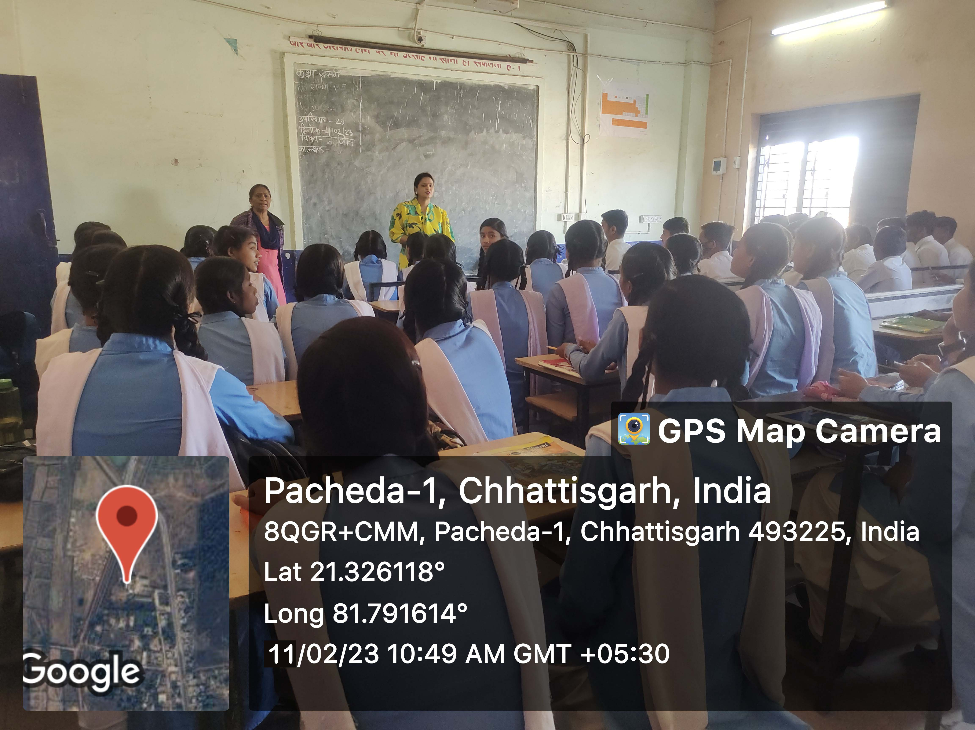
Report prepared by:-
Name & Sign : Mrs. Shrinidhi Namdeo
Designation : Assistant Professor
Contact No. : 7354021003

Mrs. Parvinder Kaur
H.o.D
MATS School of Fashion Designing

