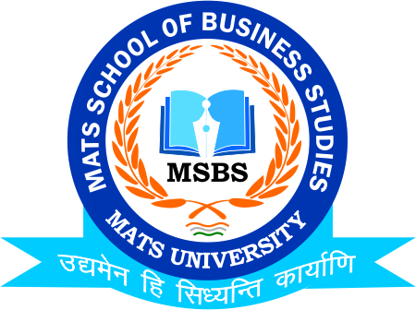
NOTICE
Yoga & Pranayam Session
Yoga Hall-MATS University Raipur Campus
27th Feb.2023

Date:24th Feb.2023
This is to inform to all the Students of B.Com/M.Com that the School of Business Studies-MATS University is going to conduct Session on “Yoga and Pranayam” on 27th Feb.2023, So all the students of respective class are instructed to be present in T-Shirt & Lowers/Paijamas on respective date and venue

Timing: 10:00 AM
Venue: Yoga Hall-MATS University Raipur Campus

Faculty Coordinator:
Mr. Deeptanshu Sharma

HOD
MSBS
Dated: 20th Feb.2023
Raipur

