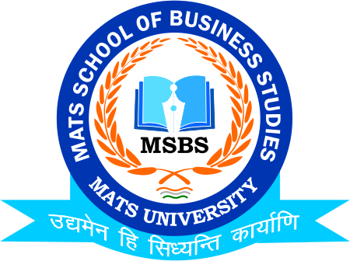
NOTICE
Talk Session- Start Up Incubation
Business Instube
22nd Feb.2023
Date:20th Feb.2023
This is to inform to all the Students of B.Com & that the MATS School of Business Studies is going to conduct Talk Session as Seminar on Business Idea Generation in coordination with Business Instube on 22nd Feb.2023, So all the students of respective class are instructed to be present
Venue: FF-133 MSBS
Timing: 12:00 PM

Faculty Coordinator:
Mr. Deeptanshu Sharma

HOD
MSBS
Dated: 20th Feb.2023
Raipur

