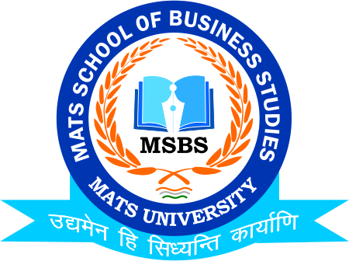
NOTICE
Online Internship Drive
Sri Ram Life Insurancw
23rd Feb.2023

Date:20th Feb.2023
This is to inform to all the Students of B.Com that the School of Business Studies-MATS University is going to conduct Online Interview Session for Internship by Sri Life Insurance on 23rd Feb.2023, So all the students of respective class are instructed to be present online in Zoom App, for which the link has been mailed to respective Email Id’s

Timing: 2:00 PM

Faculty Coordinator:
Mr. Deeptanshu Sharma

HOD
MSBS
Dated: 20th Feb.2023
Raipur

