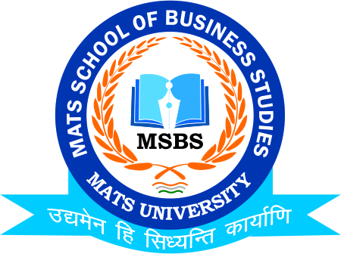
NOTICE
Central Placement Cell
Training Placement Induction Session
6th March 2023

Date:2nd March 2023
This is to inform to all the Students of B.Com/M.Com that the School of Business & Management Studies-MATS University is going to conduct Session on “Soft Skills” on 6th March 2023, So all the students of respective class are instructed to be present on respective date and venue

Timing: 10:00 AM
Venue:FF-108 MSMSR

Faculty Coordinator:
Mr. Deeptanshu Sharma

HOD
MSBS
Dated: 2nd March 2023
Raipur

