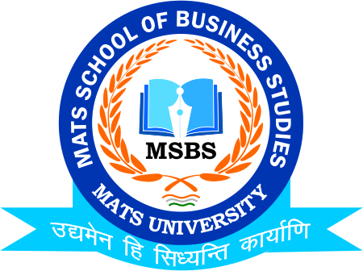
NOTICE
International Conference
School of Business & Management Studies-MATS University
Chhattisgarh Research Conclave
17th & 18th March 2023

Date:10th March 2023
This is to inform to all the Students of B.Com/M.Com/BBA/MBA that the School of Business & Management Studies-MATS University is going to conduct two days International Conference on 17th & 18th March 2023 on “Global Economic & Financial Transformation: Impact on Development”So all the students of respective class are instructed to register & be present on respective date and venue

Timing: 9:30 AM
Venue: New Convention Hall, Circuit House, Civil Lines Raipur

Faculty Coordinator:
Mr. Deeptanshu Sharma

HOD
MSBS
Dated: 10th March 2023
Raipur

