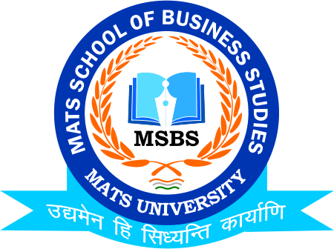

**NOTICE**

**Educational Visit to 36@Inc-Work Space*(City Centre-Raipur)***

**Date: 17th November 2021**

**Date: 16th November 2021**

This is to inform to all the Students of **B.Com (Hon.) III Semester** that **MATS School of Business Studies** in coordination with **StartUp Unit** is going to organize one day workshop on **Start Up Incubation** on **17th November 2021,** So all the Students of respective Classes are instructed to assemble at the Venue well on time and register their names to **Mr.Deeptanshu Sharma & Dr.Payal Sharma**

**HOD**

**MSBS**

**Dated: 16th November 2021**

**Raipur**