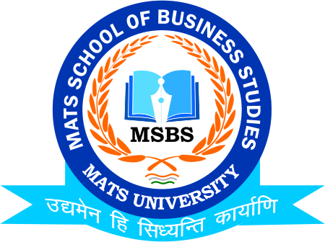
NOTICE
Placement Drive- Rama Motors (Tata Motors)
Venue-Bhanpuri Near Banjari Mandir
14th Feb.2023

Date:9th Feb. 2023
This is to inform to all the Students of B.Com-6th Semester (Hons.) that the MATS School of Business Studies is going to conduct Placement Drive in Off Campus Mode in Rama Motors (Unit of Tata Motors) on 14th Feb.2023, So all the registered students of respective class are instructed to be present
Venue: Rama Motors, Near Banjari Mandir, Bhanpuri Raipur
Timing: 02:00 pm

Faculty Coordinator:
Mr. Deeptanshu Sharma

HOD
MSBS
Dated: 9th Feb.2023
Raipur

