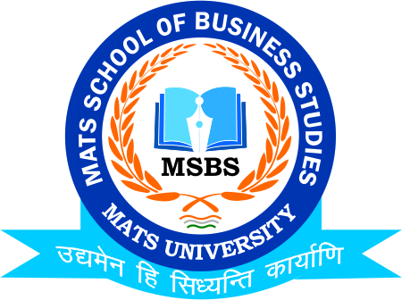
NOTICE
Maha Arti/Hawan (Ganeshotsav)
Date: 18th Sept.2021

Date:17th September 2021

This is to inform to all the Students of B.Com & M.Com that the MATS School of Business Studies in coordination with MATS University is going to organize its Singing Competition/ Maha Arti & Hawan Pooja for Ganeshotsav on 18th September 2021. So, all the Students of respective Classes are instructed to assemble at the Venue well on time and register their names to Program Coordinators

HOD
MSBS
Dated: 16th September 2021
Raipur

