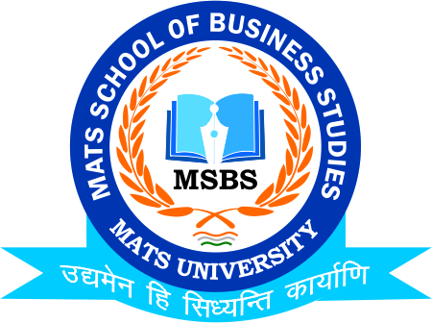
NOTICE
Final Project Viva
BCom-VI/MCom-II/MCom-IV
1st-2nd-3rd May 2023

Date: 8th April 2023
This is to inform to all the Students of BCom & MCom II-VI Semester that the School of Business Studies-MATS University is going to conduct Final Project Viva on 1st-2nd-3rd May 2023 so all the students of respective class are instructed to register & be present on respective date and venue

Timing: 10:00 to 3:00 pm
Venue: MSBS FF-134
Date: 1st to 3rd May 2023

Faculty Coordinator:
Mr. Deeptanshu Sharma

HOD
MSBS
Dated: 8th April 2023
Raipur

