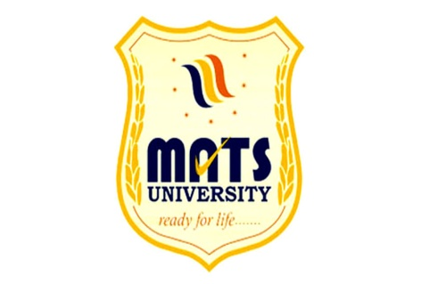
MATS UNIVERSITY
Main Campus – Gullu (Arang), Raipur-493441 CG
Main Campus-MATS Tower, Pandari, Raipur-192002 CG
Tel: 0771-4078995, 4078996 Fax:0771-4078997
E-mail: info@matsuniuversity.ac.in website:www.matsuniversity.ac.in

To,
……………………………….
……………………………….
Subject: - Application for (One Day) Educational Visit
Respected Sir/Mam
With due respect we School of Business Studies- MATS University would like to introduce you as one of the biggest private university in Chhattisgarh which has the highest ranking by NAAC (B++) UGC
We would like to conduct an Educational Visit with our students of MBA for academic purpose and practical exposure
So, kindly provide us the date when we can visit with Students at Nalanda Parisar
Participation of Students:- 15 Approx (Excluding 02 Faculties)
Raipur
Date:10th December 2021
Dr.Umesh Gupta
Prof. & Head
School of Business Studies
MATS University

