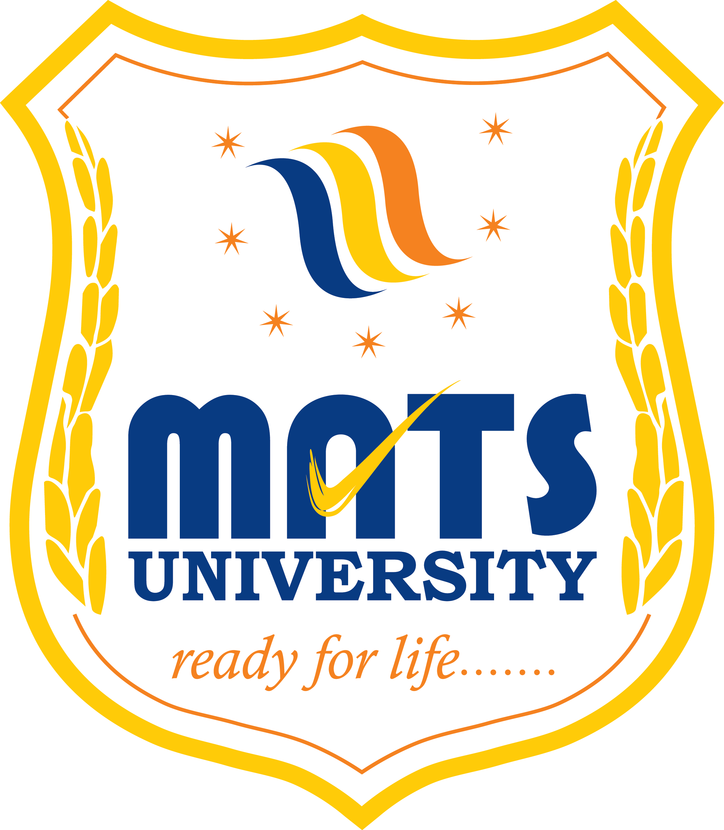
MATS SCHOOL OF FASHION DESIGNING & TECHNOLOGY
EVENT/ ACTIVITY REPORT [Month: SEP-2022]
- Event Details:
- Organized under the aegis of : MATS University, Raipur
- Title : MARKET SURVEY ACTIVITY
- Date : 24/09/2022
- Time : 11:30 AM
- Venue : HANDLOOM EPO, AKASHVANI SQUARE, Raipur.
- Mode : Offline
- Type : Visit

2. Attendees/ Participants:
(a) Resource Persons:
(1)

(b) Faculty Attended/ Participated (By Institution/ Programme):

School Name | No. of Faculty attended | Grand Total
MSFDT | 02 | 02

(c) Students Participated (By Institution/ Programme/ Semester).

School (in brief) | Program/Course | Semester | Total No. of students | Grand Total
MSFDT | B.Sc FDT | 5th SEM | 16 | 16

3. Event/ Activity coordinator(s):
(1) Mrs. Preeti Bhatt
(2) Mrs. Somya Upadhyay

4. Brief description about the event/ activity:
MATS School Of Fashion Designing & Technology has performed MARKET SURVEY ACTIVITY for the Fashion designing students about cloth materials. We gave various detailed knowledge about the cloth materials like Phulkari work material, Chikankari work material, Banarasi Silk material and kosa silk material. They have also displayed some wood carving products as artifacts.
We gave brief knowledge about Handloom Carpets, Silver Metal Jewellery selection and Traditional footwear (Mojari jutti) selection as per the dress.

5. Learning Outcomes:
- Market Survey Activity was good and students did it well along with their teacher.
- Students are happy to attend this market survey Activity.
- They gained lots of knowledge about the cloth materials.

6. Photographs: (Geo-tagged photographs)
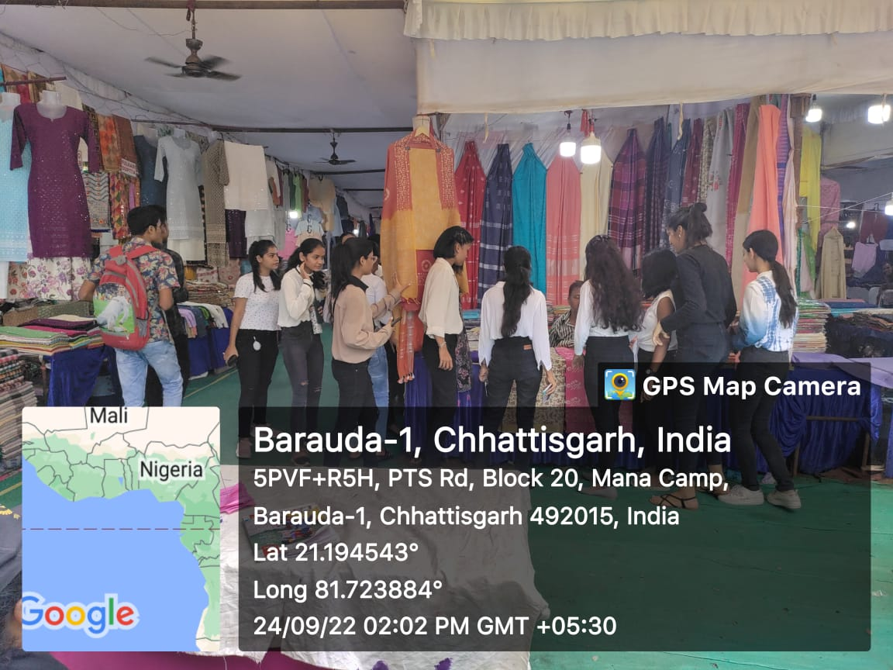
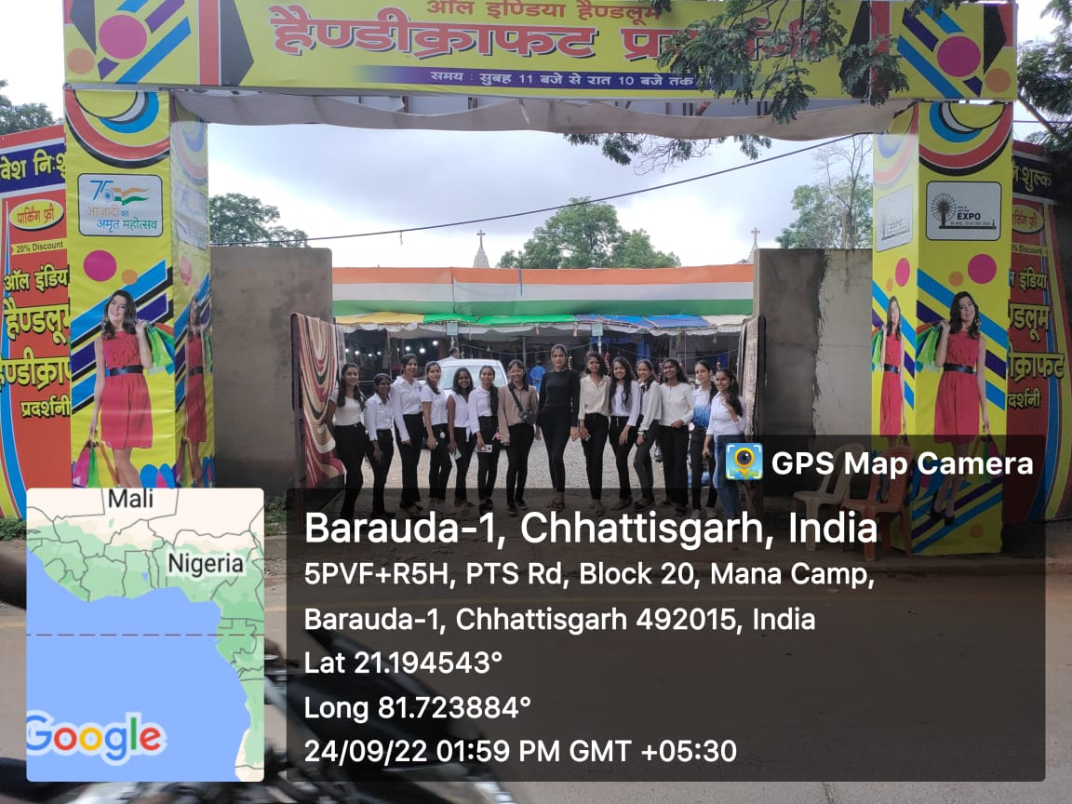

Report prepared by:-
Name & Sign : Mrs. Shrinidhi Namdeo
Designation : Assistant Professor
Contact No. : 7354021003

