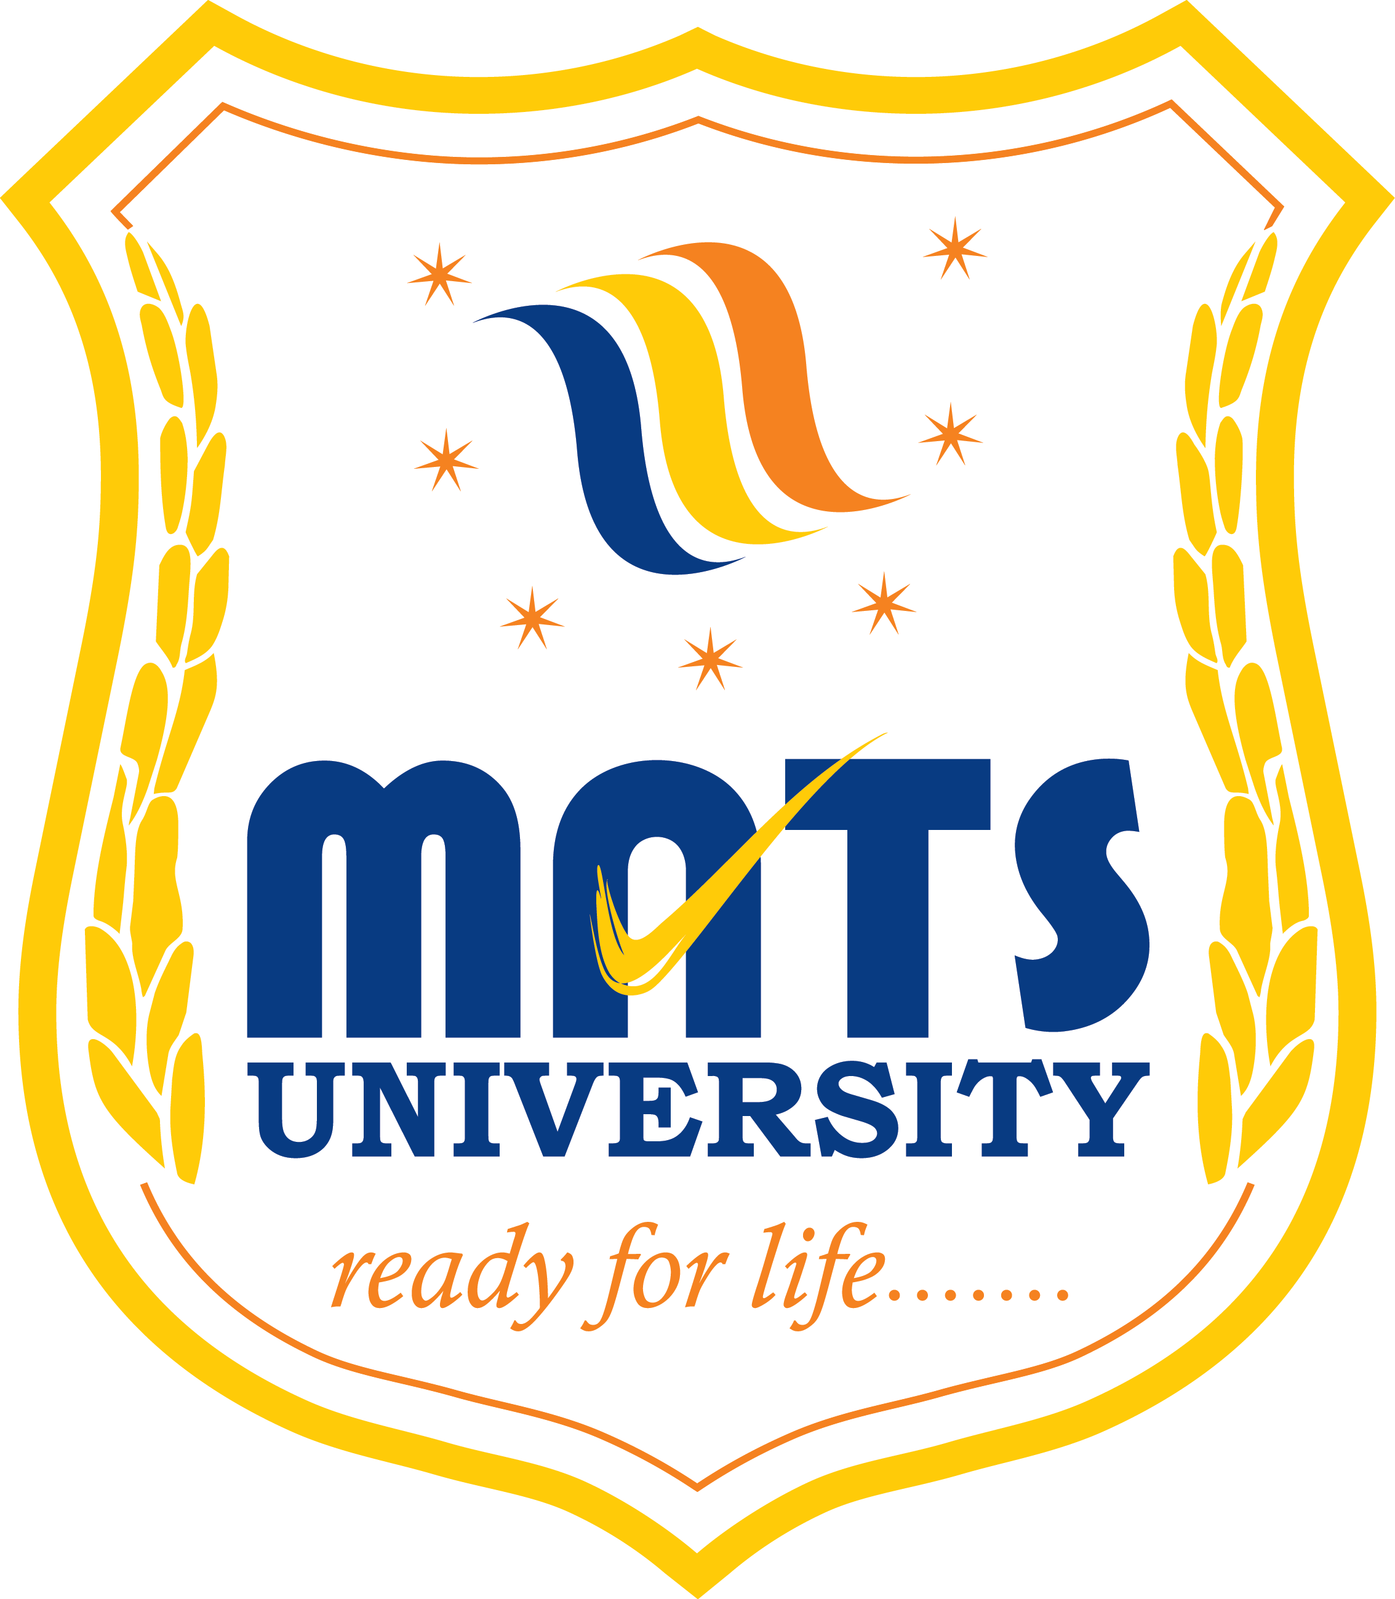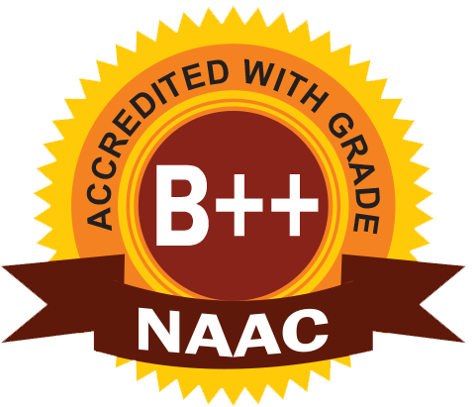
MATS SCHOOL OF FASHION DESIGNING & TECHNOLOGY
EVENT/ ACTIVITY REPORT [Month: SEP-2022]
- Event Details:
- Organized under the aegis of : MATS University, Raipur
- Title : ISR ACTIVITY
- Date : 12/09/2022
- Time : 02:00 PM
- Venue : AIRPORT ROAD, MANA, Raipur.
- Mode : Offline
- Type : Visit

2. Attendees/ Participants:
(a) Resource Persons:
(1) N/A

(b) Faculty Attended/ Participated (By Institution/ Programme):

School Name | No. of Faculty attended | Grand Total
MSFDT | 02 | 02

(c) Students Participated (By Institution/ Programme/ Semester).

School (in brief) | Program/Course | Semester | Total No. of students | Grand Total
MSFDT | B.Sc FDT | 5th | 8 | 08

3. Event/ Activity coordinator(s):
(1) Mrs. Preeti Bhatt
(2) Mrs. Vijaya Vaishnava

4. Brief description about the event/ activity:

MATS School Of Fashion Designing & Technology has performed Activity regarding awareness on “NO PLASTIC BAG USE” in daily basis and they have distributed Cloth Bags to use for their daily need requirement.

5. Learning Outcomes:
- ISR Activity was good and students did it well along with their teachers.
- The people who were attending this ISR Activity were very happy to have this kind of Activity.
- Participants gained the knowledge regarding NOT TO USE PLASTICS and keep the environment safe and healthy.
6. Photographs: (Geo-tagged photographs)

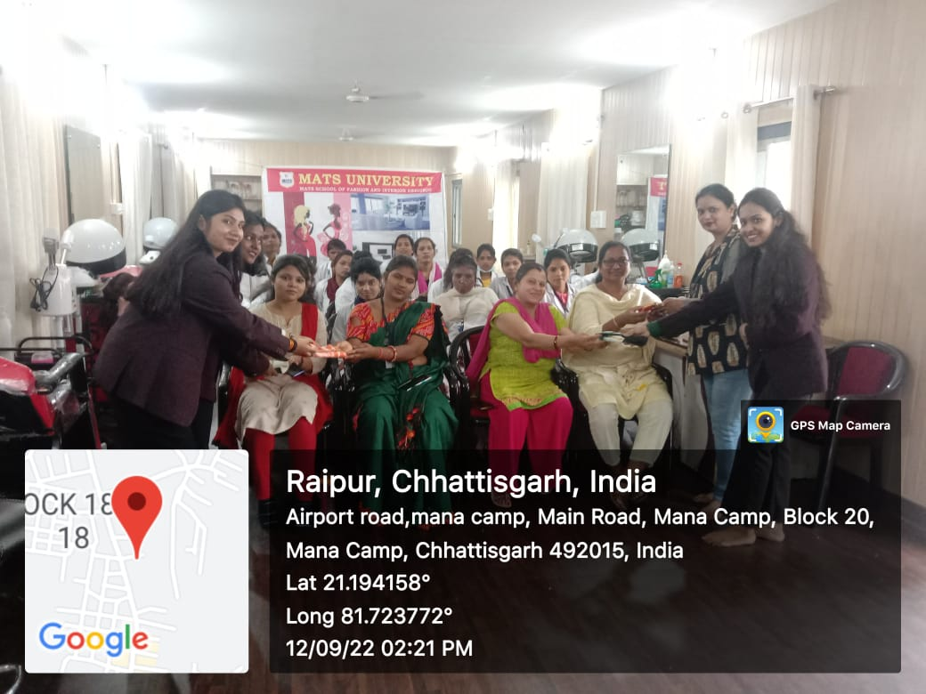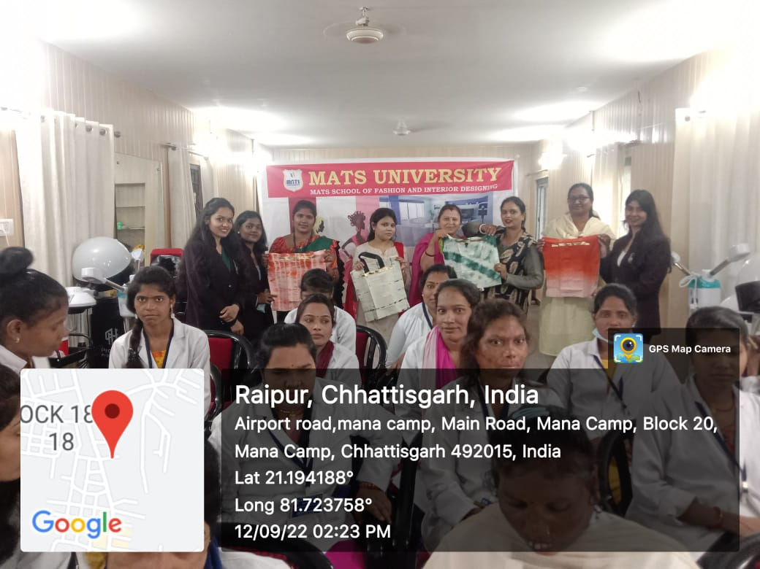

Report prepared by:-
Name & Sign : Mrs. Shrinidhi Namdeo
Designation : Assistant Professor
Contact No. : 7354021003

