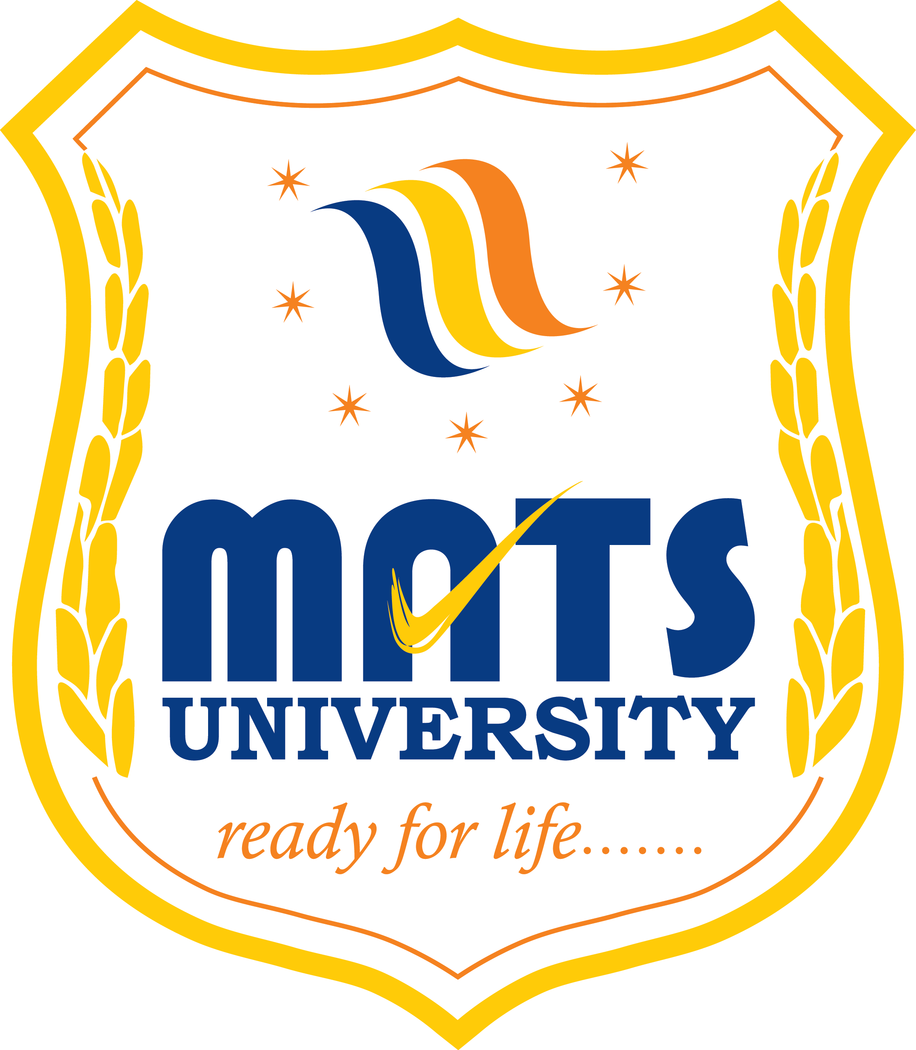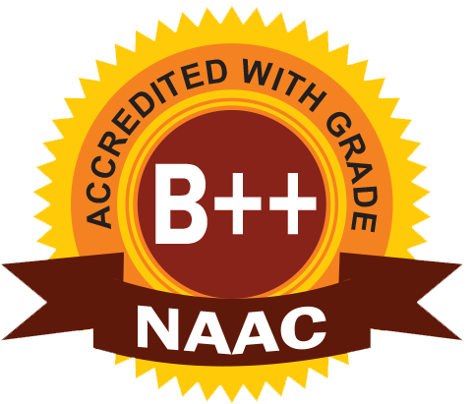
MATS SCHOOL OF FASHION DESIGNING & TECHNOLOGY
EVENT/ ACTIVITY REPORT [Month: DEC-2022]
- Event Details:
- Organized under the aegis of : MATS University, Raipur
- Title : ISR ACTIVITY
- Date : 03/12/2022
- Time : 02:00 PM
- Venue : MATS University, Raipur.
- Mode : Offline
- Type : Visit

2. Attendees/ Participants:
(a) Resource Persons:
(1) N/A

(b) Faculty Attended/ Participated (By Institution/ Programme):

School Name | No. of Faculty attended | Grand Total
MSFDT | 02 | 02

(c) Students Participated (By Institution/ Programme/ Semester).

School (in brief) | Program/Course | Semester | Total No. of students | Grand Total
Asti Badhit Baal Garha | B.Sc FDT | 3rd | 08 | 08

3. Event/ Activity coordinator(s):
(1) Mrs. Preeti Bhatt
(2) Mrs. Vijaya Vaishnava

4. Brief description about the event/ activity:

MATS School of Fashion Designing & Technology has conducted ”ISR Activity” on Dressing Awareness for specially challenged people. On the occasion of “International Day of Disabled Person” which was on 3rd Dec 2022, student of fashion design have design designer dresses for them to look awesome and smart. Students of fashion design made them aware of dressing as per their need and comfort.
They explained about how to choose the perfect dress for themselves and how to look smart.
Special students learnt from our fashion designing student about the styling and dressing, how to get well dressed and builds confidence.
Our student displayed their designer clothes to motivate them for their future.

5. Learning Outcomes:
- ISR Activity was motivating and students did it well.
- The people who were attending this ISR activity were glad to have inspiring activity like this.
- Participants gained the knowledge regarding dressing awareness.

6. Photographs: (Geo-tagged photographs)

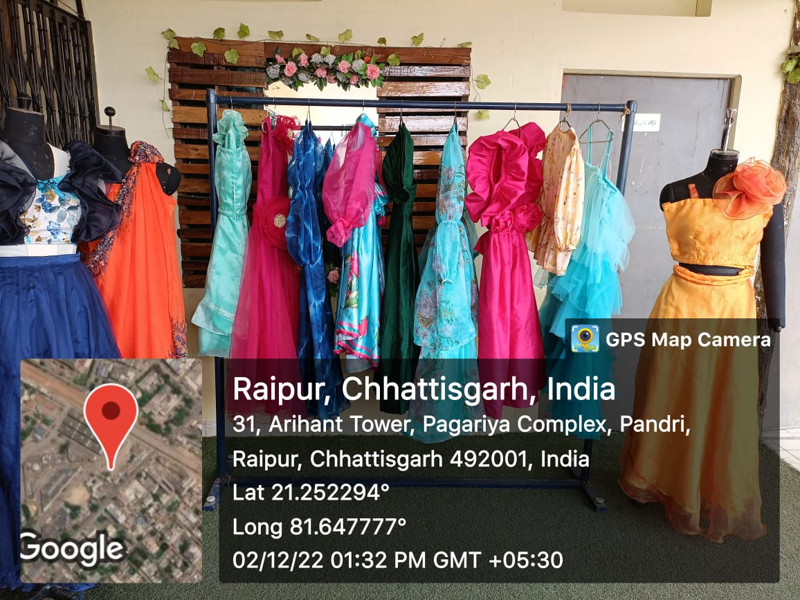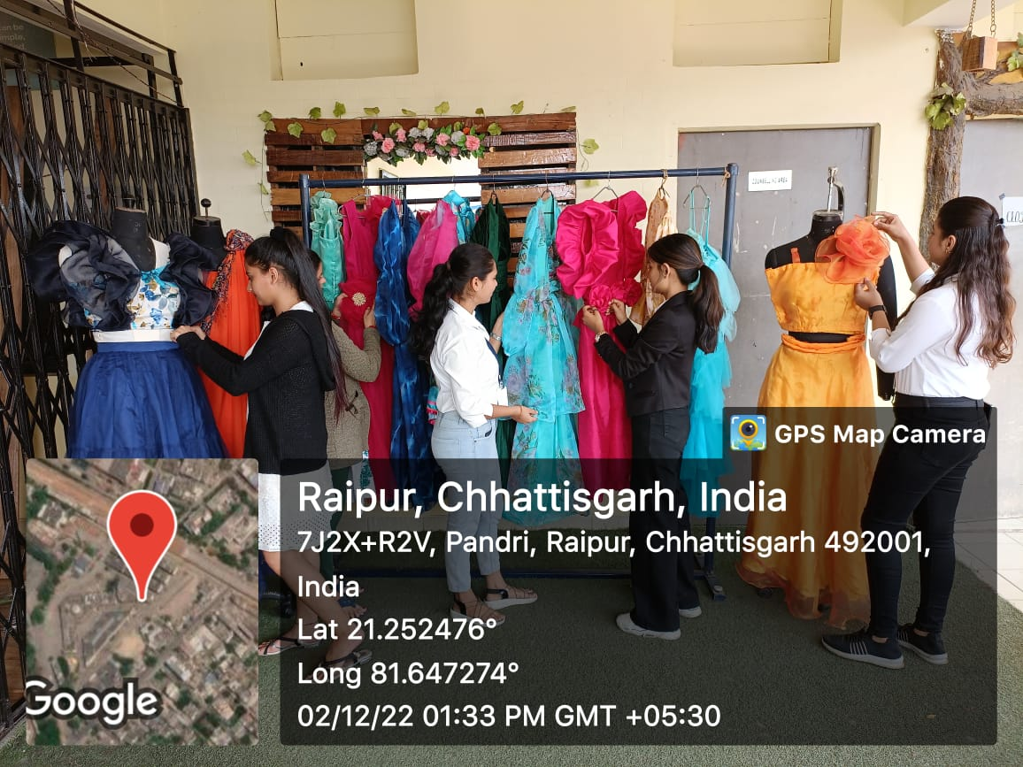

Report prepared by:-
Name & Sign : Mrs. Shrinidhi Namdeo
Designation : Assistant Professor
Contact No. : 7354021003

Mrs. Parvinder Kaur
H.O.D
MATS School of Fashion Designing

