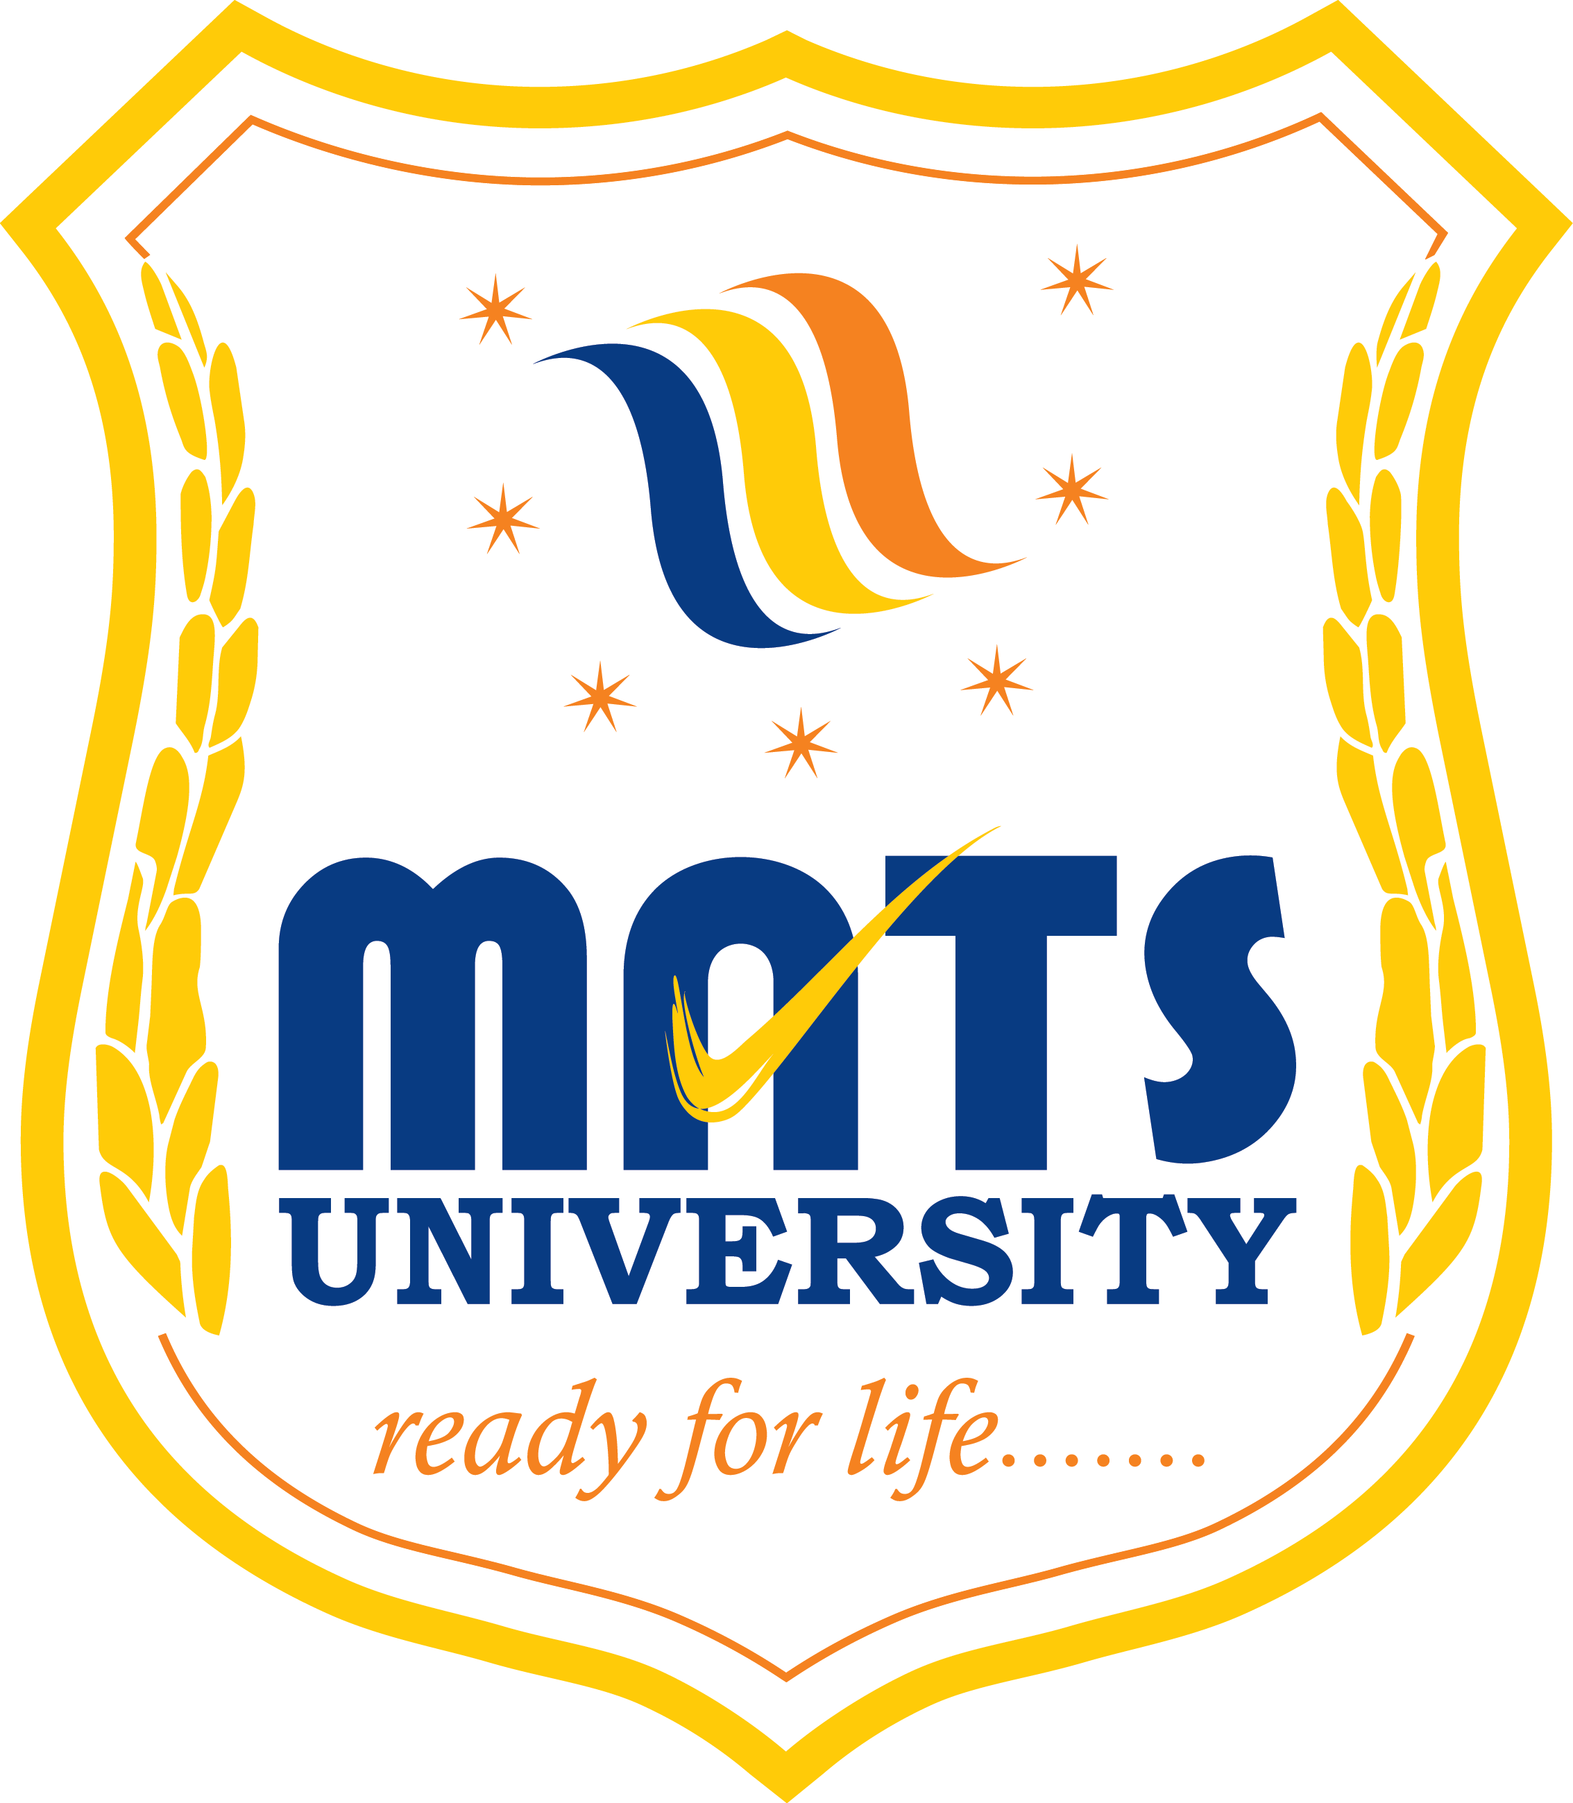
MATS SCHOOL OF FASHION DESIGNING & TECHNOLOGY
EVENT/ ACTIVITY REPORT [Month: SEP-2022]
- Event Details:
- Organized under the aegis of : MATS University, Raipur
- Title : GENDER EQUALITY ACTIVITY.
- Date : 14/09/2022
- Time : 01:00 PM
- Venue : MATS UNIVERSITY, Pandri, Raipur.
- Mode : Offline
- Type : Visit

2. Attendees/ Participants:
(a) Resource Persons:
(1) N/A
(b) Faculty Attended/ Participated (By Institution/ Programme):

School Name | No. of Faculty attended | Grand Total
MSFDT | 02 | 02

(c) Students Participated (By Institution/ Programme/ Semester).

School (in brief) | Program/Course | Semester | Total No. of students | Grand Total
MSFDT | B.Sc FDT | 5th
 | B.Sc FDT | 3RD
 | B.Sc FDT | 1ST
 | B.Sc IDT | 5th
 | B.Sc IDT | 3RD
 | B.Sc IDT | 1ST
 | B.Sc MDT
 | B.Sc MDT

3. Event/ Activity coordinator(s):
(1) Mr. Satyam Vaishnava
(2) Mrs. Hetal Desai

4. Brief description about the event/ activity:

MATS School Of Fashion Designing & Technology has performed Activity regarding awareness about the Gender equality in our society. Transgender Community people came to MATS University to share their problems they face when they shop cloths for them in the market. They say that they are unable to find cloths as per there body structure and fitting cloths.
So they want our bright fashion designing student to design cloths as per their requirements.3345
They had scheduled The Pride Parade on March 18th 2022.
5. Learning Outcomes:
- Gender equality Activity Awareness was good and students understood their issues they are facing and student will try to help them.
- All the Students of MATS SCHOOL OF FASHION DESIGN AND TECHNOLOGY participated very actively in this activity and all the members from this community also enjoyed sharing us.

6. Photographs: (Geo-tagged photographs)

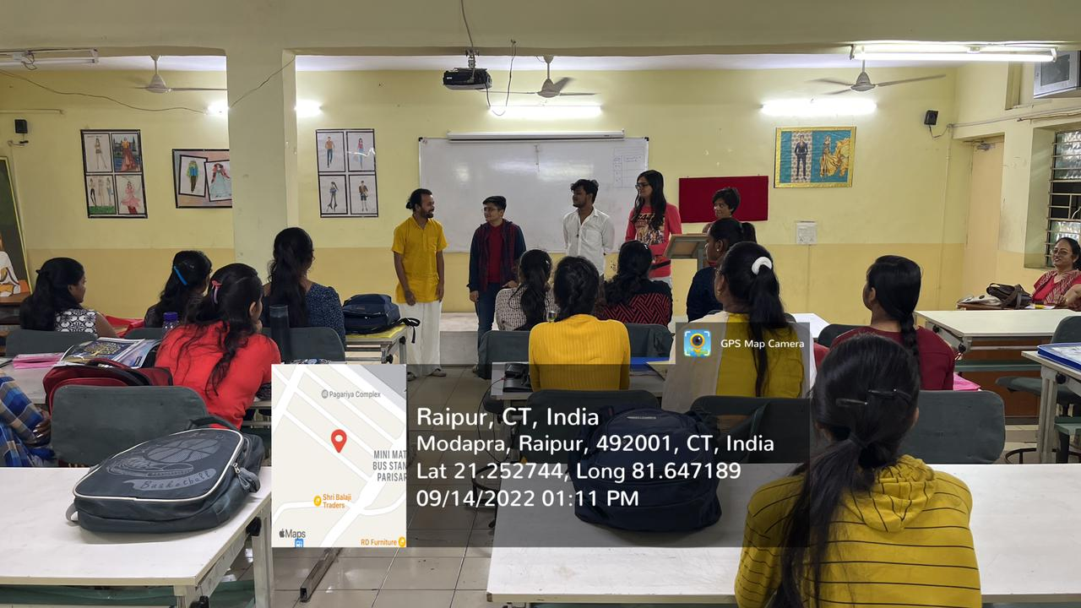
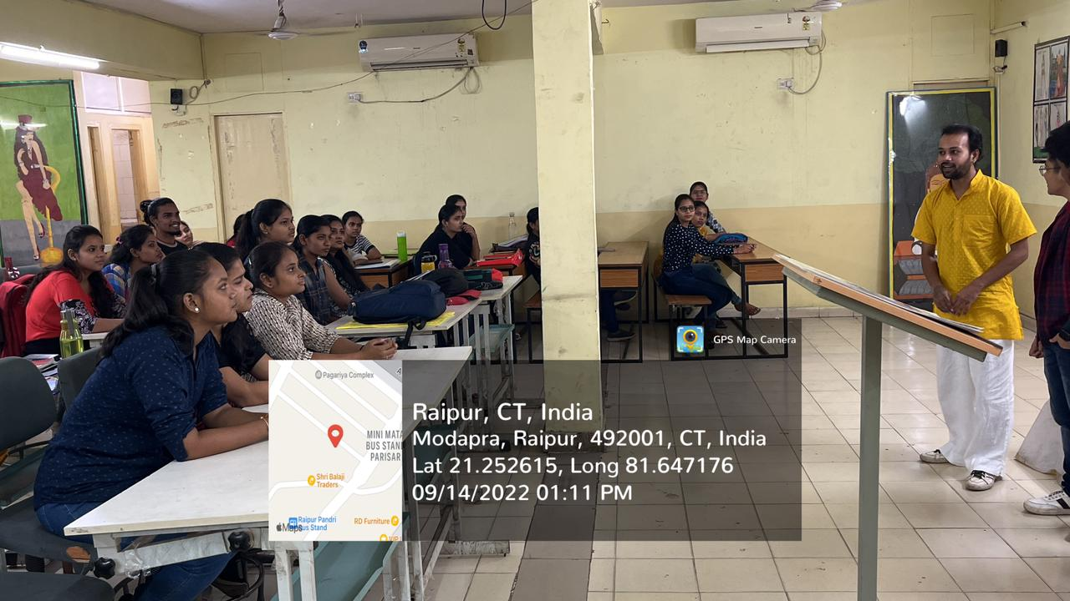

Report prepared by:-
Name & Sign : Mrs. Shrinidhi Namdeo
Designation : Assistant Professor
Contact No. : 7354021003

