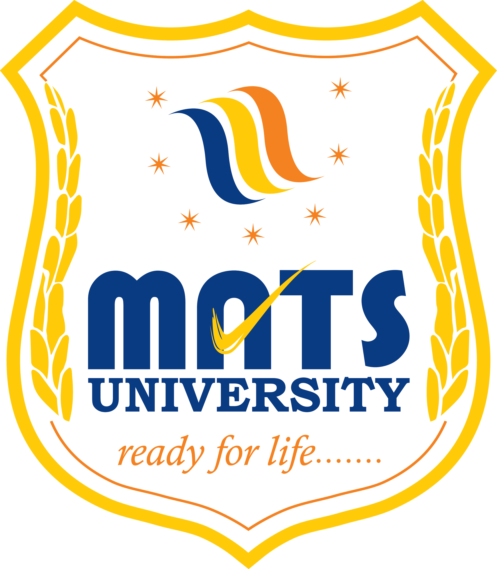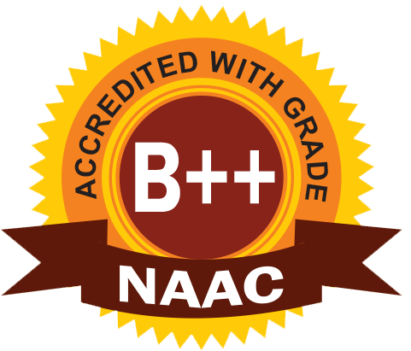
MATS SCHOOL OF FASHION DESIGNING & TECHNOLOGY
EVENT/ ACTIVITY REPORT [Month: NOV-2022]
- Event Details:
- Organized under the aegis of : MATS University, Raipur
- Title : RESIN ART.
- Date : 01/11/2022 to 12/11/2022
- Time : 2:00 to 5:00 PM
- Venue : MATS University, Raipur.
- Mode : Offline
- Type : Visit

2. Attendees/ Participants:
(a) Faculty Attended/ Participated (By Institution/ Programme):

School Name | No. of Faculty attended | Grand Total
MSFDT | 01 | 01

(b) Students Participated (By Institution/ Programme/ Semester).

School (in brief) | Program/Course | Semester | Total No. of students | Grand Total
Mats School of Fashion Designing & Technology | BSC.FDT | III | 9 | 9

3. Event/ Activity coordinator(s):

(1) Ms. Somya Upadhyay

4. Brief description about the event/ activity:

MATS School of Fashion Designing & Technology has conducted “RESIN ART” for student of first year Fashion design. Mrs. Alka Halwat was taking classes for Resin Art.
She is teaching to make jewelry with Resin Art. Students are making beautiful items like jewelry, key rings with their name initials, etc.
Resin art is important art to learn for the Fashion designing students. Because, of its multiple usage for designing anything we like. Resin is best to create abstract works of arts.
After this value added course, Students can make their customized and innovative jewelry for the designer dress as per their need.
Once they will learn how to use resin to create attractive decorative things for the fashion designing purpose, then they will get more innovative ideas for better creations.

5. Learning Outcomes:
- Students are excited to have this innovative courses well organized by the MATS University for the students.
- Students were motivated to make their Resin Art along with the teacher.

6. Photographs: (Geo-tagged photographs)
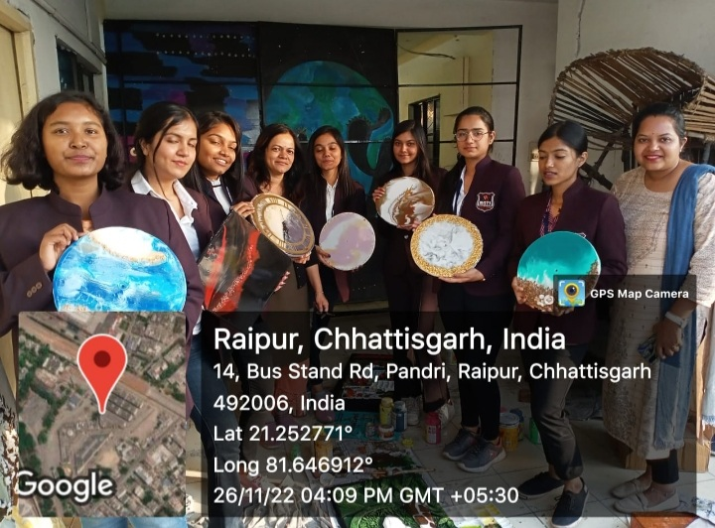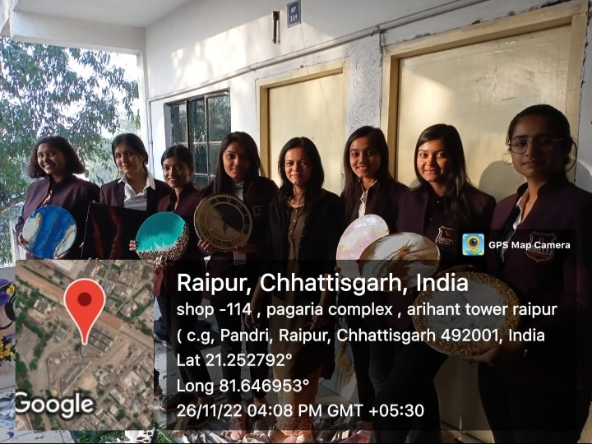

Report prepared by:-
Name & Sign : Mrs. Shrinidhi Namdeo
Designation : Assistant Professor
Contact No. : 7354021003

Mrs. Parvinder Kaur
H.O.D
MATS School of Fashion Designing & Technology

