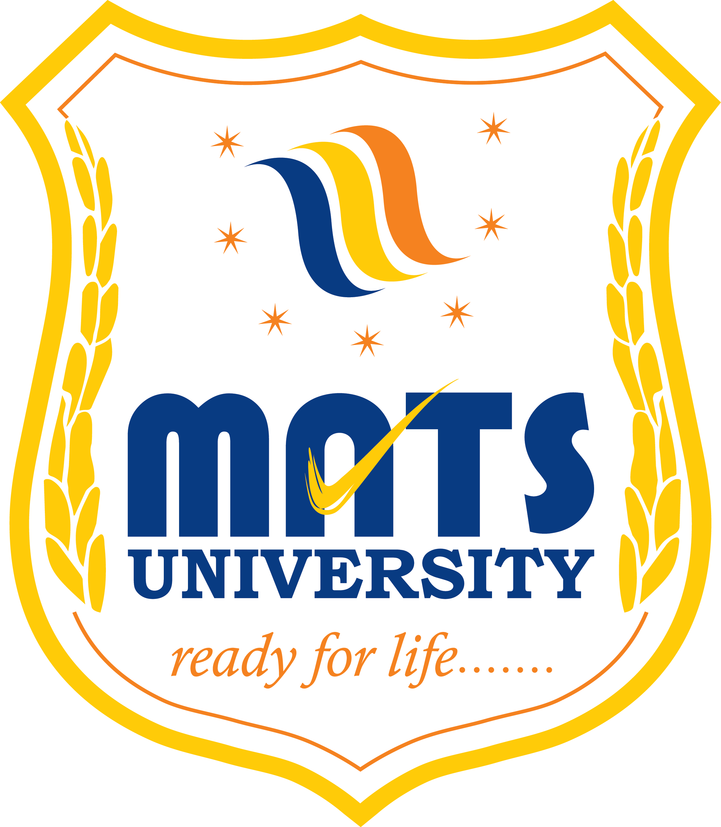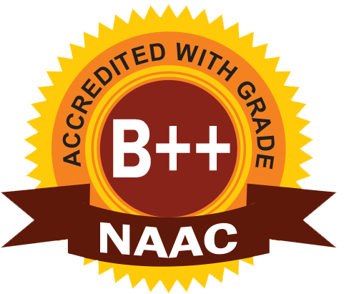
MATS SCHOOL OF FASHION DESIGNING & TECHNOLOGY
EVENT/ ACTIVITY REPORT [Month: NOV-2022]
- Event Details:
- Organized under the aegis of : MATS University, Raipur
- Title : ORIANA FASHION SHOW 2022.
- Date : 02/11/2022
- Time : 06:00 PM
- Venue : AIIMS, Raipur.
- Mode : Offline
- Type : Visit

2. Attendees/ Participants:
(a) Faculty Attended/ Participated (By Institution/ Programme):

School Name | No. of Faculty attended | Grand Total
MSFDT | 03 | 03

(b) Students Participated (By Institution/ Programme/ Semester).

School (in brief) | Program/Course | Semester | Total No. of students | Grand Total
Mats School of Fashion Designing & Technology | BSc.FDT | V, I | 19 | 19

3. Event/ Activity coordinator(s):
(1) Ms. Somya Upadhyay
(2) Mrs. Hetal Desai
(3) Mr. Satyam Vishwakarma

4. Brief description about the event/ activity:

Students of MATS School of Fashion Designing & Technology has participated ORIANA 2022 AIIMS FASHION SHOW competition on 2nd Nov 2022.
Students of Fashion Designing 5th Semester, 12 students participated in the fashion show competition.
Our university presented the theme – “Trinetraa” it was all about Lord shiva devotees, Aghori and Monk
The Theme delivered the message about unity among both devotees. Students wore their self-designed outfits. Key elements of design were hand painting and embellishments.
Khadi fabric was used for garment construction for promoting sustainable fashion.
Students wore hand crafted footwear which is called “khhadau”.
The make-up showcased and enhanced their look with an add-on of face painting. The props and stage
Decoration were designed and made by students themselves.
They secured 1st position in the fashion show and got 30,000 cash prize and gift vouchers worth up to 4 lakh.
They were well appreciated by the audience at the fashion show event competition.

5. Learning Outcomes:
- Fashion shows are important as they showcase the new styles of the season.
- Students were motivated and glad to perform on national fashion show platform.
- Students achieved lots of confidencec and knowledge from this activity.
- They won the first prize at AIMS ORIANA FASION SHOW COMPETITION.

6. Photographs: (Geo-tagged photographs)
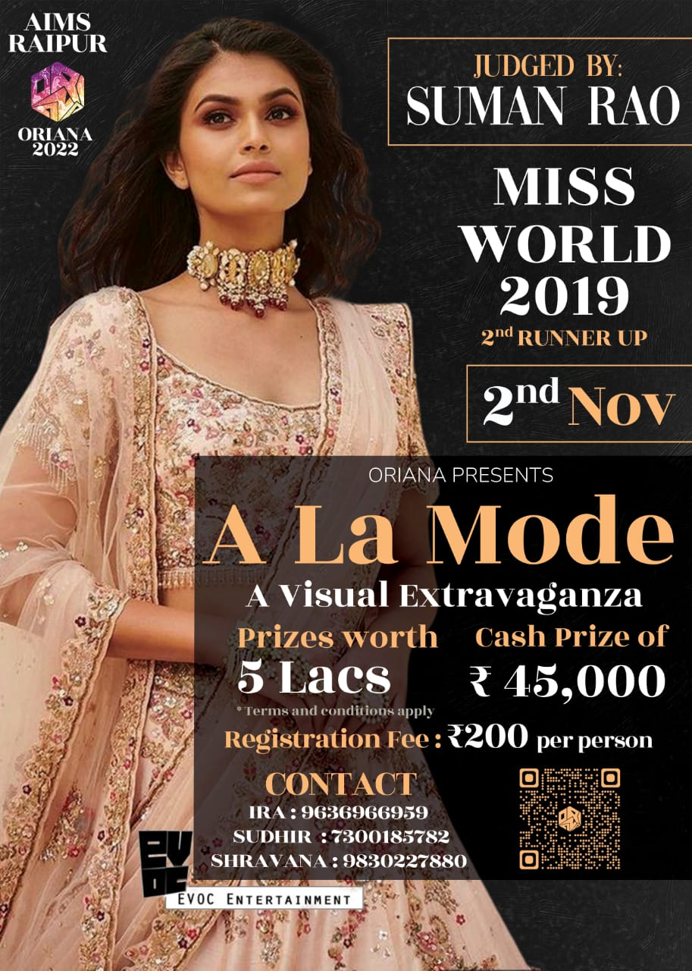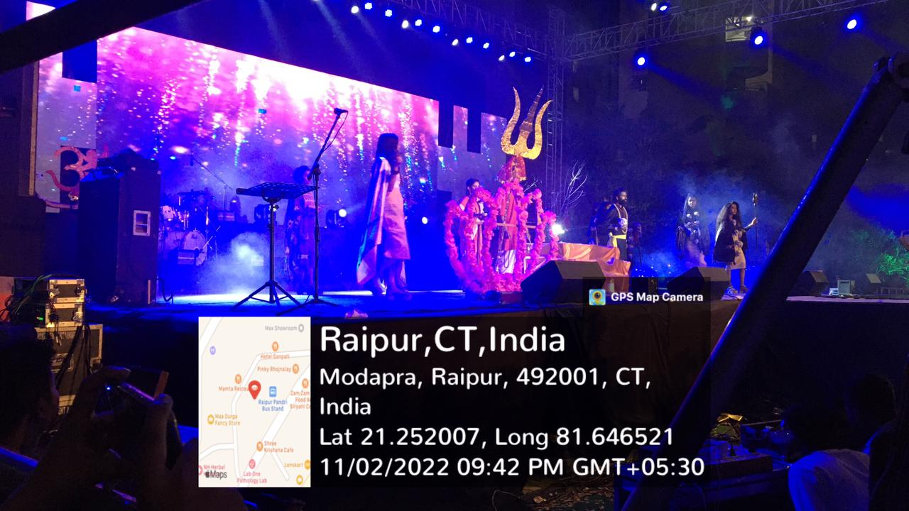
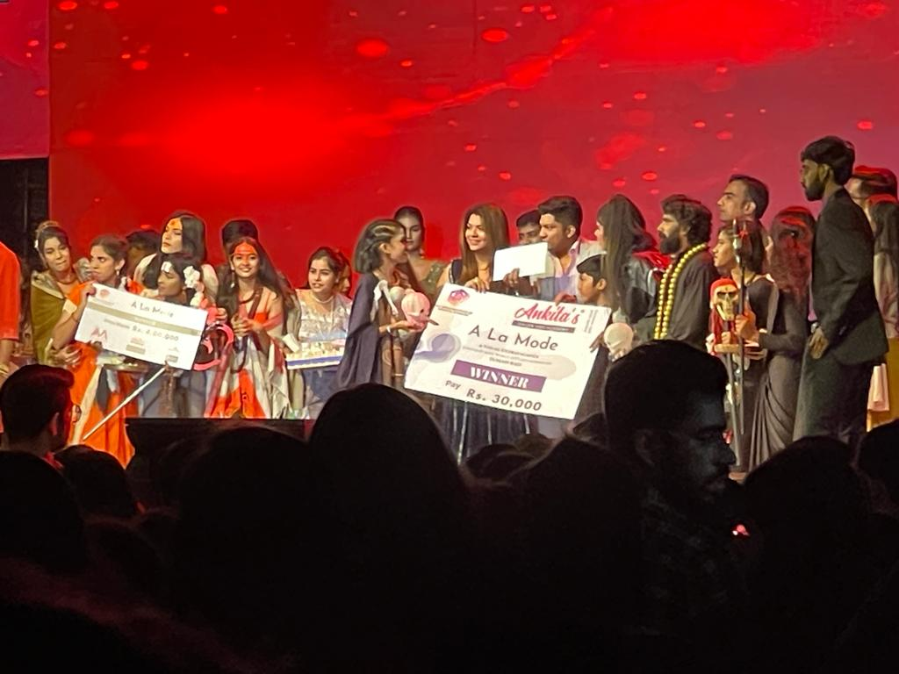

Report prepared by:-
Name & Sign : Mrs. Shrinidhi Namdeo
Designation : Assistant Professor
Contact No. : 7354021003

Mrs. Parvinder Kaur
H.O.D
MATS School of Fashion Designing & Technology

