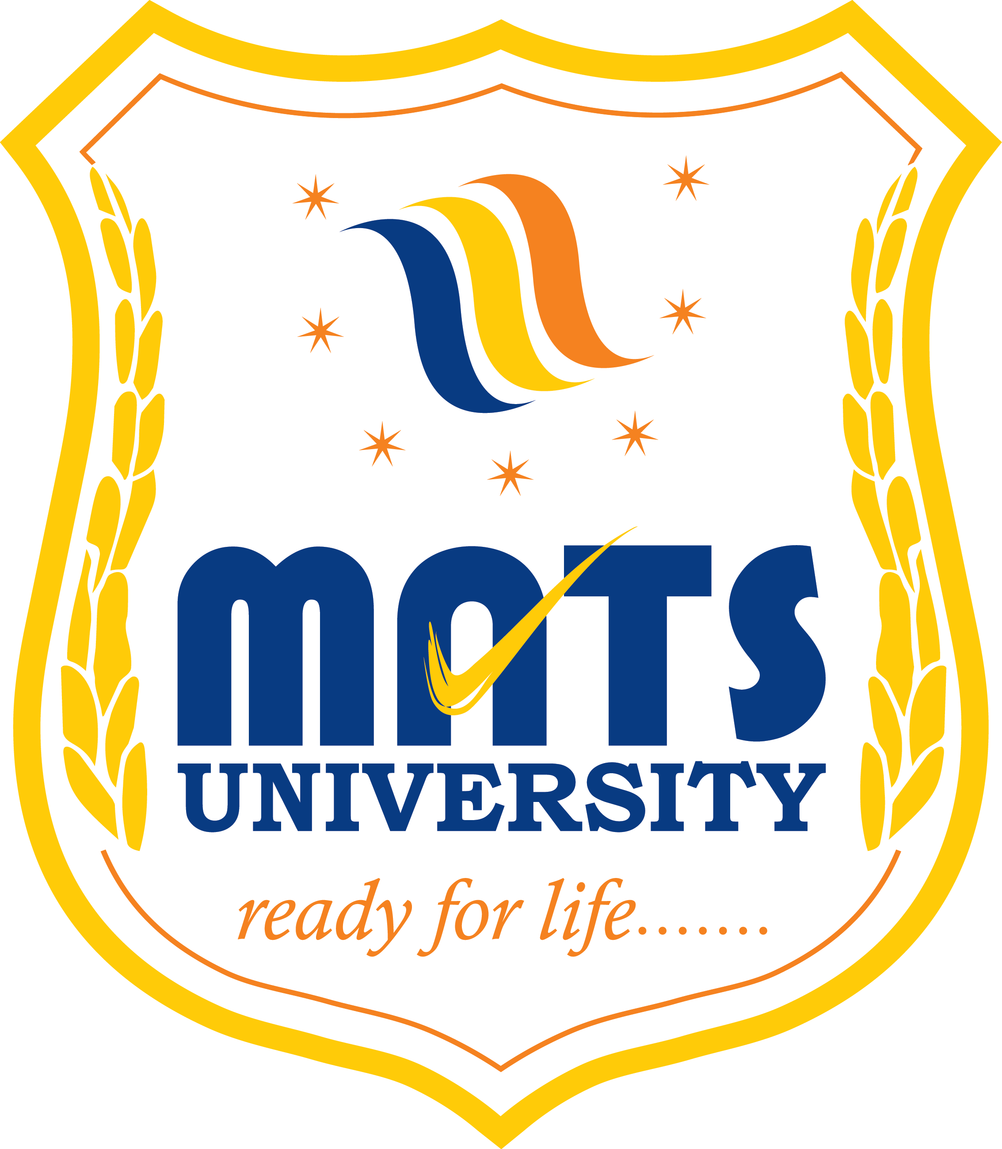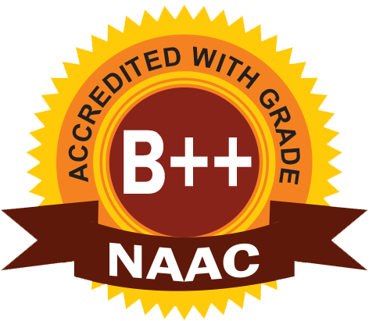
MATS SCHOOL OF FASHION DESIGNING & TECHNOLOGY
EVENT/ ACTIVITY REPORT [Month: OCTOBER-2022]
- Event Details:
- Organized under the aegis of : MATS University, Raipur
- Title : KHADI FASHION SHOWS ACTIVITY.
- Date : 01/10/2022
- Time : 02:30 PM
- Venue : MATS University, pandri, Raipur.
- Mode : Offline
- Type : Visit

2. Attendees/ Participants:
(a) Faculty Attended/ Participated (By Institution/ Programme):

School Name | No. of Faculty attended | Grand Total
MSFDT | 04 | 04

(b) Students Participated (By Institution/ Programme/ Semester).

School (in brief) | Program/Course | Semester | Total No. of students | Grand Total
Mats School of Fashion Designing & Technology | BSc.FDT | I III V

3. Event/ Activity coordinator(s):
(1) Mrs. Preeti Bhatt
(2) Mrs. Vijaya Vaishnava
(3) Ms. Somya Upadhyay
(4) Mr. Satyam Vishwakarma

4. Brief description about the event/ activity:

On the occasion of Gandhi Jayanti, “KHADI FASHION SHOWS - SUT” was organized by MATS School of Fashion Designing & Technology.
The aim of the event was to promote rural khadi traditional dress by presenting Indian Culture through natural manmade fabrics.
The chief guest of the event was Mrs. Ritu Jain wife of Mr. Amitabh jain, chief secretary, who described the event as commendable. We welcomed her with Flowers and tika.
The program was inaugurated by the chancellor of MATS University Shri Priyes Pagaria, Vice chancellor Prof. KP Yadav, Registrar Shri Gokulananda Panda, Head of Department Mrs. Parvinder Kaur.
The special characteristics of khadi fabric is that they are eco-friendly and comfortable.
Fashion designing students of all the semester participated with different fashion shows theme.
Student did hand panting on khadi fabrics and created stylish garments like Skirts, Stoles, Sarees and tops with embellishments.
Students had designed handmade fashionable jewelry to match with their outfits. They used jute rope, cloth and some artificial flowers to design their jewelry. This was a part of their innovative designing.
They presented with “Charkha” as a main stage prop.
Interior designing students presented a dance performance.

5. Learning Outcomes:
- Fashion shows are important as they showcase the new styles of the season.
- Students were motivated and glad to perform the fashion show.
- Students achieved lots of confidencec and knowledge from this activity.

6. Photographs: (Geo-tagged photographs)
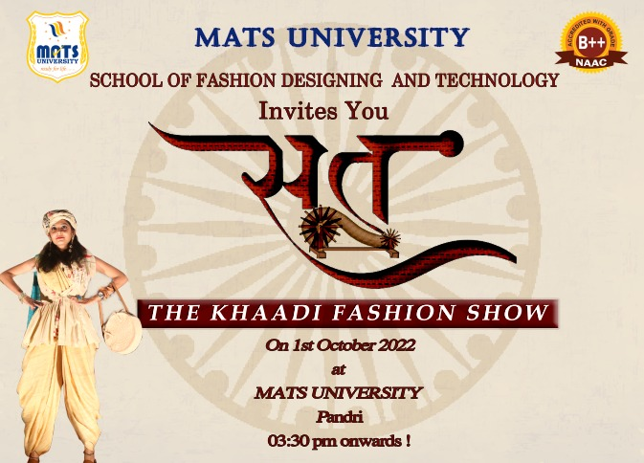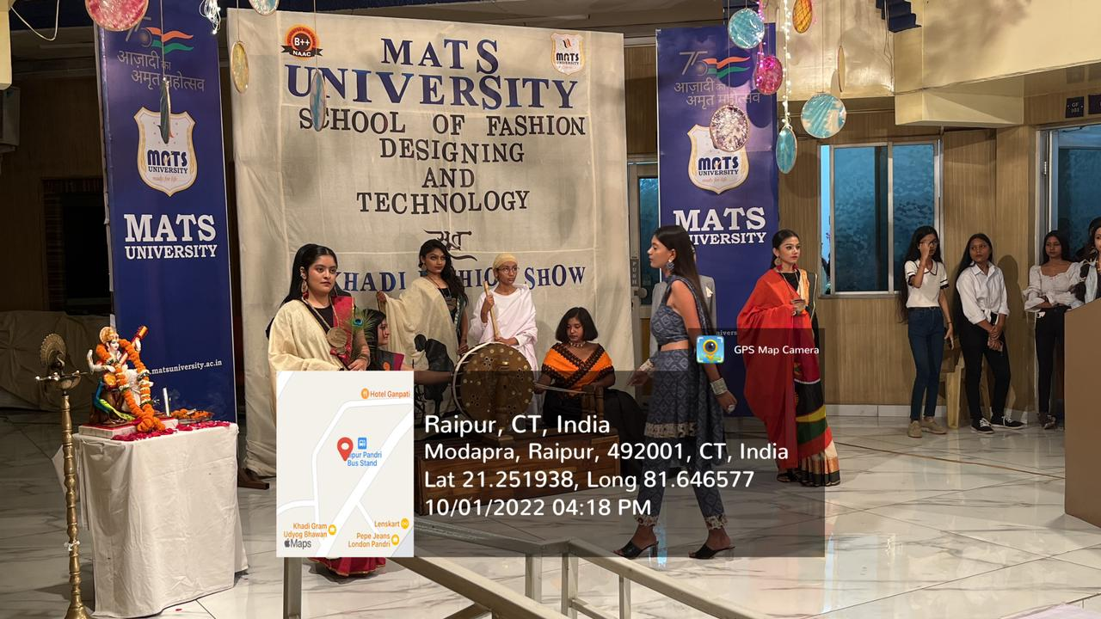
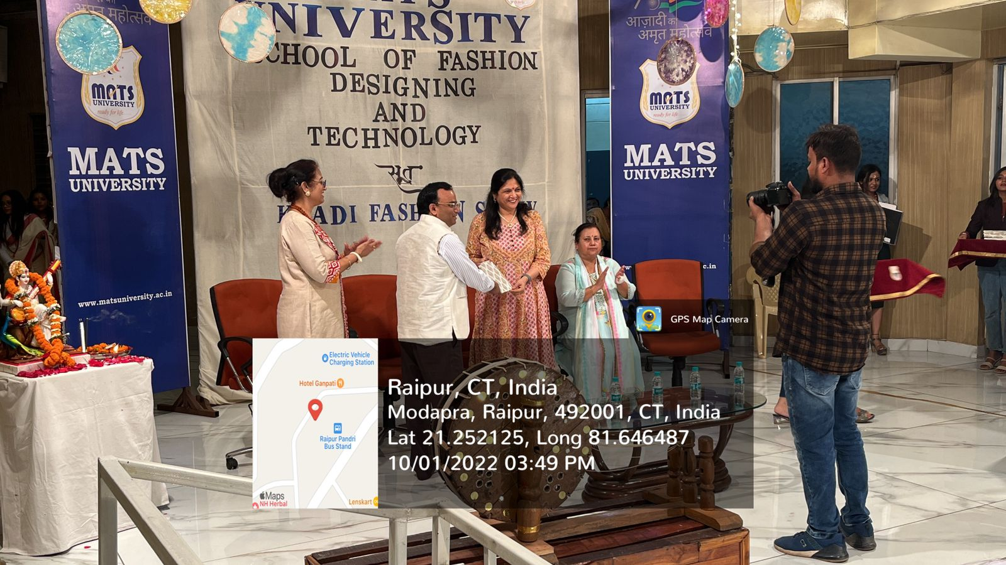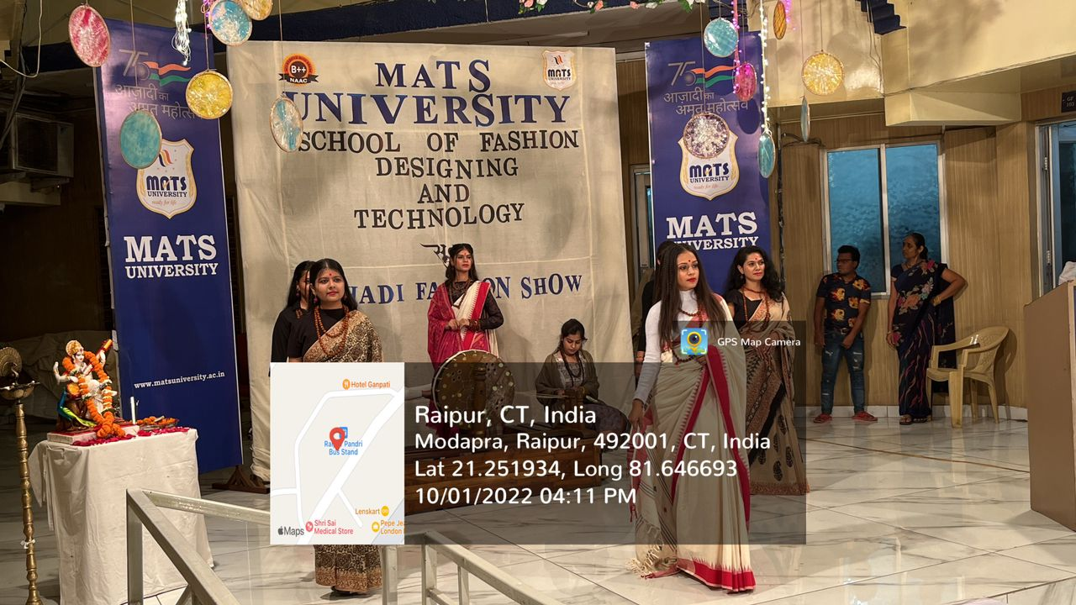
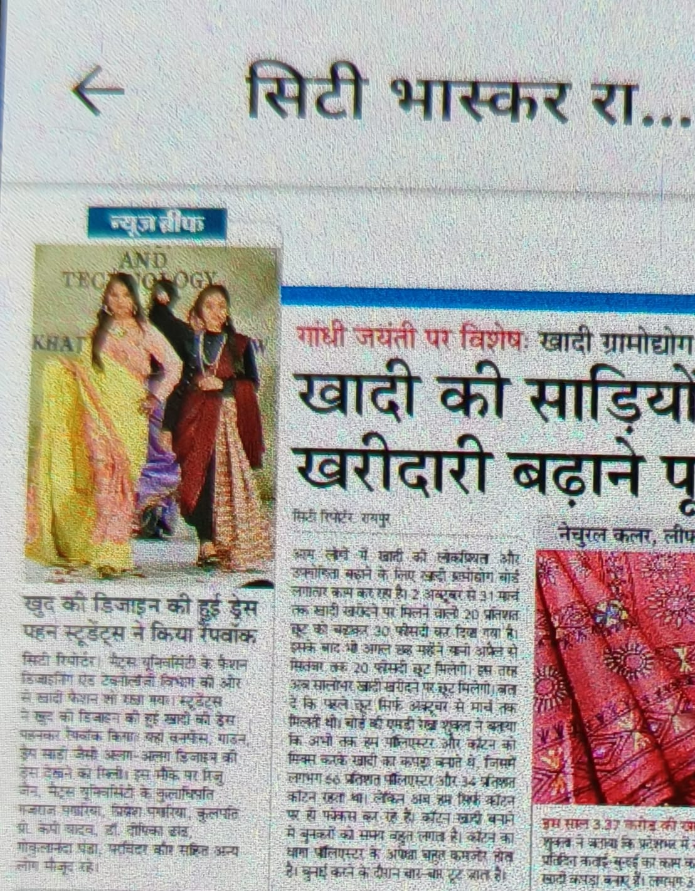

Report prepared by:-
Name & Sign : Mrs. Shrinidhi Namdeo
Designation : Assistant Professor
Contact No. : 7354021003

Mrs. Parvinder Kaur
H.O.D
MATS School of Fashion Designing & Technology

