CM TALKS

The beginning
On 15thJuly 2022, the interview with the Chief Minister of Chhattisgarh Mr. Bhupesh Baghel and other Ministers of his Cabinet was commenced at 3:00 PM, at Hotel Babylon Inn, Raipur.
The interview was hosted by a renowned news channel ‘Hindi Khabar’which featured the CEO of the channel Mr. Atul Agrawal as the representative.
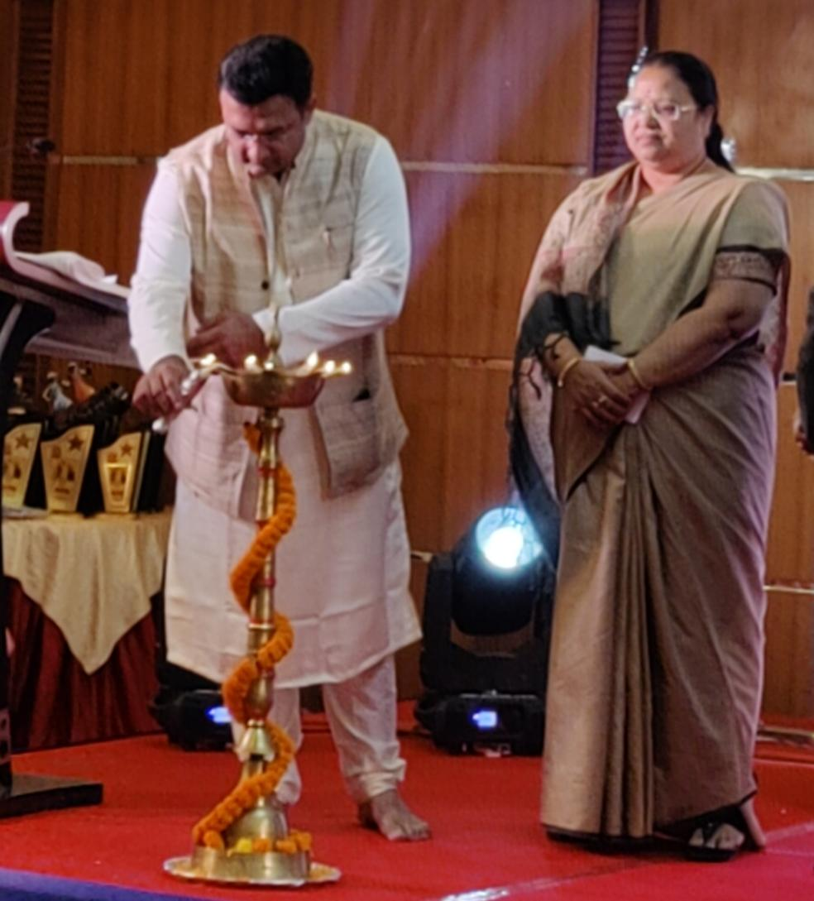
The session began at 3:00 PM, when Mrs. Ahila Bhediya (Minister of Women and Children welfare) was invited to inaugurate the event by liting the lamp. Further Mr. Atul welcomed her to the seat for proceeding with the Interview.
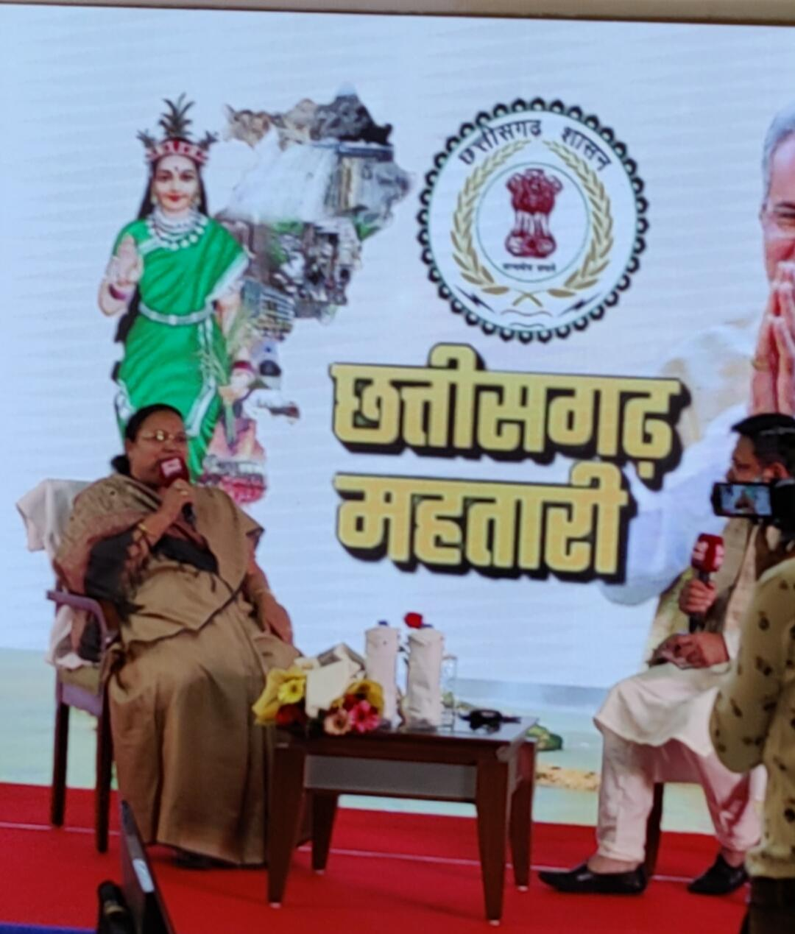
The question round started with Ahila ji being asked about the challenges she faced throughout her journey to which she replied that there had been people talking bad about her but she always has a positive mindset and support of her family to overcome any difficult situations.
She was then questioned about the condition of vulnerable women who becomes the victim of toxic male cruelty, to which she replied that it’s the wrong mindset of those who do cruelty to the women and government is constantly taking action against them. Later Mr. Atul asked her about what steps is the government taking for the betterment of condition of women in children belonging from the vulnerable groups to which she replied that government is running multiple schemes and providing free medical and healthcare facilities to the needful.
Ahila ji was then honored for her presence and had left the interview thereafter.
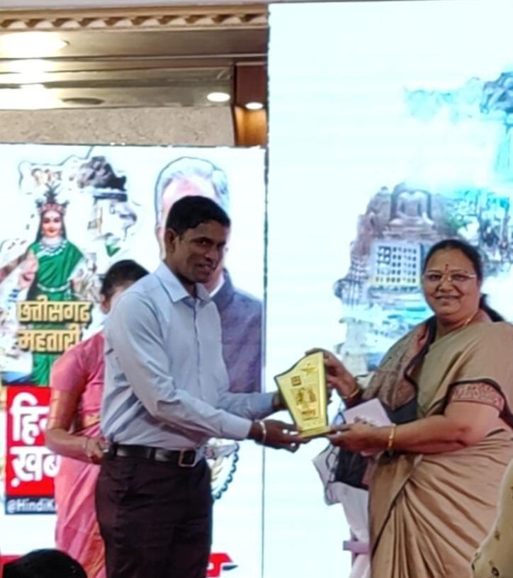
The Chief Minister arrived at 4:30 PM and was warm welcomed and interviewed by Mr. Atul Agrawal.
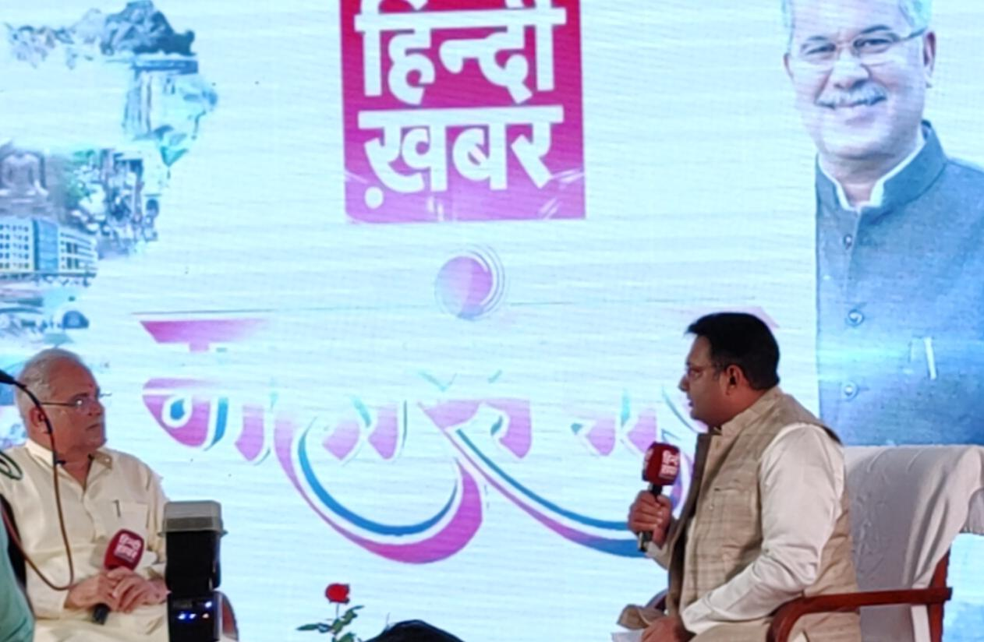
The question session began with Mr. Baghel being asked about existence of Naxalism and the negative impact on prestige of the state to which he replied that under his government everything is settled in peaceful way and there has been no terror caused by the Naxalites under his rule.
Mr. Baghel continued talking about the localites of tribal region and added that his government is providing them with free ration, education, healthcare and other needful commodities for living.
He was then questioned about how the government of Chhattisgarh had controlled the situation of COVID and had grown up the economy in those hard times to which he replied that the model of his government and his ministers are very proficient and they work day and night for the betterment of the state
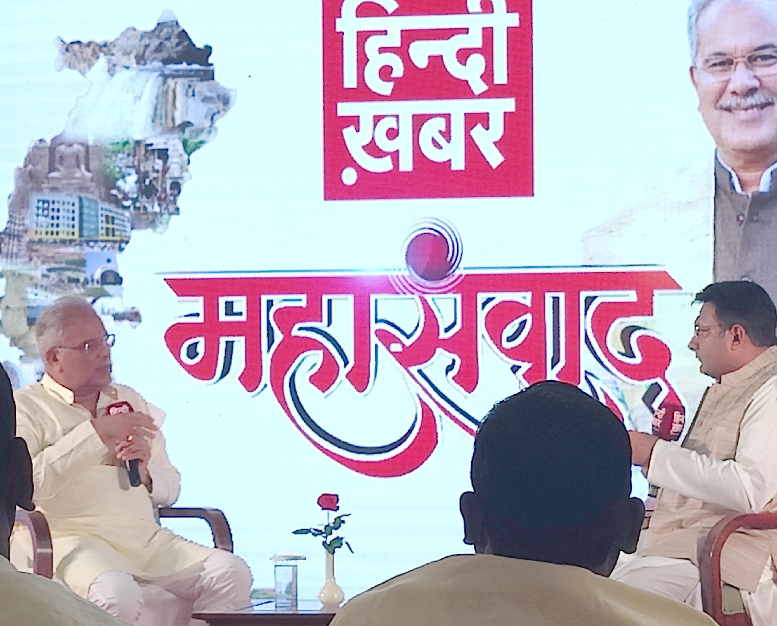
The CM talks about the scarcity of needful resources during the COVID era and he stated that the Central Government was not being very supportive towards the Chhattisgarh Government.
Mr. Baghel was then requested by the host to sing a song on the request of audience and he sang ‘Jhupar’ which is a ‘Chhattisgarhi Song’.
The interview ends with CM being honored to talk about topic of his choice to which he spoke about the future visionof his government for the betterment of the state. He then awarded the recipients for their achievements.
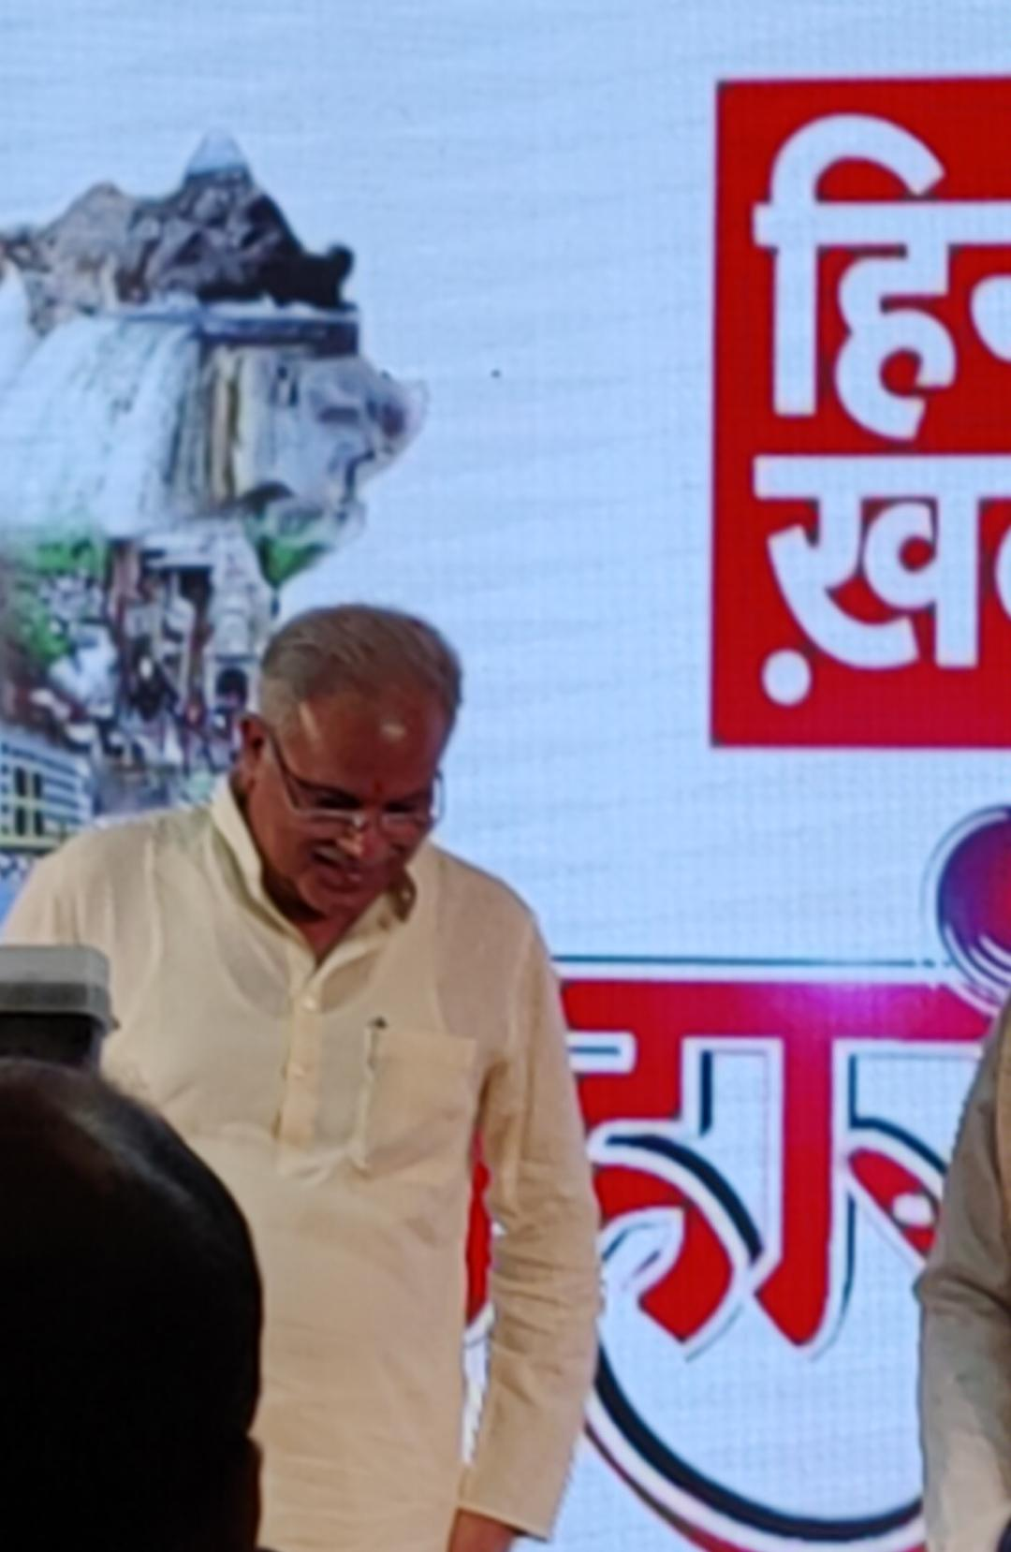
The CM exited after the award ceremony.
Later we got an opportunity to be in a frame with Mr. Atul Agrawal (CEO Hindi Khabar) it was really joyful meeting and interacting with him and we got to learn many valuable lessons from him.
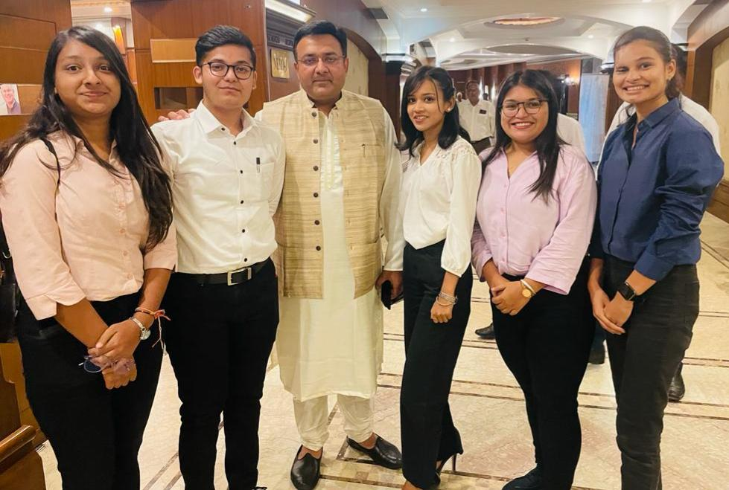
Attending the conference was a great opportunity for us as we got to learn many valuable things and got to know the government better.
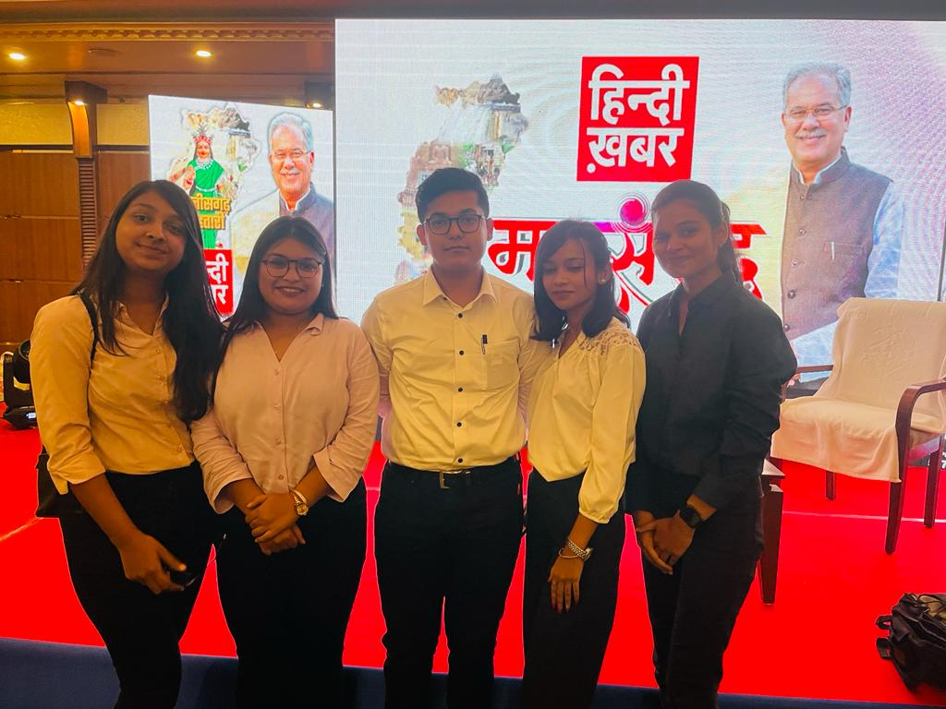
Students presented MATS UNIVERSITY:
Archee Agrawal
Nitika Sharma
Swastik Mahapatra
Shirin Rizvi
Shruti Pagaria

Report Prepared by – Swastik Mahapatra
BBA 3rd semester
MSMSR (MATS University)

